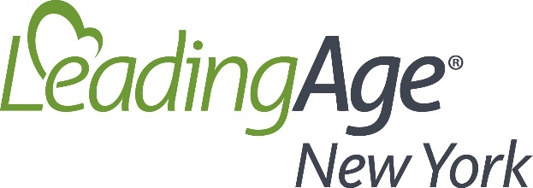
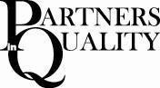

2018 Partners in Quality Legislative Awards Program

NOMINATION FORM

Please send forms via email to jdiamond@leadingageny.org or via fax to 518-867-8384 by Tuesday, July 31, 2018.

Nominee Information

Nominee’s name: District:

Select the branch of government the nominee is affiliated with: ☐ State ☐ Federal ☐ Local

Nominator’s name and title:

Nominator’s organization:

Nominator’s phone number:

Nominator’s email:

PLEASE ANSWER THE FOLLOWING:

- What issues has this legislator worked on with you throughout the past year?

- Has this official visited any site affiliated with your organization? ☐ Yes ☐ No

- Have you presented the nominee with a Partners in Quality Award in the past? ☐ Yes ☐ No

- In 200 words or less, please describe your reasons for nominating this official.

