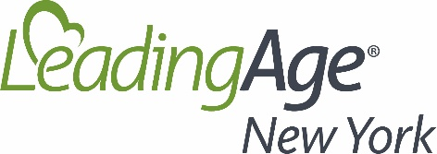
HR Council Meeting
April 7, 2022
1:00 pm to 2:00 pm
Meeting Notes

Welcome and Introductions (E. Quinn, LeadingAge New York, VP HR)
- Introduction of Co-facilitators

Area Health Education Centers (Executive Directors, Statewide AHEC)
- Discussion regarding what AHEC is and the resources they can provide.
- Build pipelines to careers
- Health career presentations to high schools
- Website lists retention strategies and offers job opening notification sites
- Questions / Discussion

Temporary Nursing Aid to CNA (Elliott Frost, LeadingAge New York, Sr. Policy Analyst, ProCare Consultant)
- Changes to facilities in TNA to CAN programs. Difficulties getting Prometrics to keep up with need.
- Questions / Discussion
Next Steps ((E. Quinn, LeadingAge New York, VP HR)
Topic Ideas:
- Refuge Resettlement Agencies throughout NYS

Next meeting:
May 5th, 2022

