

13 British American Blvd., Suite 2, Latham, New York 12110 Telephone (518) 867-8383 Web www.leadingageny.org

M E M O R A N D U M
TO: | Community Services Members
FROM: | Cheryl Udell, Community Services Policy Analyst
DATE: | November 16, 2015
SUBJECT: | Home Health Agency Final Medicare Rule for 2016
ROUTE TO: | Administrator/Director, CFO

ABSTRACT: CMS releases HHA PPS Final Rule for CY 2016.

Introduction

The Centers for Medicare and Medicaid Services (CMS) have issued the Home Health Agency Prospective Payment System (HHA PPS) Final Rule for Calendar Year (CY) 2016. The complete rule is published in the Nov. 5, 2015 Federal Register.

CMS estimates that based upon the most recent available data approximately 3.5 million beneficiaries receive home health services from nearly 11,850 HHAs, resulting in an annual Medicare expenditure of approximately $17.9 billion.

Overall Impact and Summary of Key Provisions

CMS projects that Medicare payments to HHAs in CY will be reduced by 1.4 percent, or $260 million, down slightly from the 1.8 percent decrease as found in the original Proposed Rule.

The final net 1.4 percent reduction reflects the following factors:

- The 1.9 percent* home health payment update percentage ($345 million increase);
- A 0.9 percent decrease in payments due to the 0.97 percent payment reduction to the national, standardized 60-day episode payment rate to account for nominal case-mix growth from 2012 through 2014 ($165 million decrease); and
- A 2.4 percent decrease in payments due to the third year of the four-year phase-in of the rebasing adjustments to the national, standardized 60-day episode payment rate, the national per-visit payment rates, and the non-routine medical supplies (NRS) conversion factor ($440 million decrease).

*The CY 2016 HH market basket update is 2.3 percent which is then reduced by a multi-factor productivity (MFP) adjustment of 0.4 percentage points. The resulting HH payment update is equal to 1.9 percent.

In addition, CMS has finalized the new initiative designed to support greater quality and efficiency among HHAs by implementing the Home Health Value-Based Purchasing (HH VBP) model. Compared to the proposed rule, the maximum payment reduction in the first year will be in keeping with other VBP models. Originally proposed at 5 percent, it is down to 3 percent in the Final Rule. The HH VBP model is projected to save millions of dollars attributable to a reduction in unnecessary hospitalizations and Skilled Nursing Facility (SNF) usage.

In CY 2015, CMS implemented a wage index transition policy consisting of a 50/50 blend of the old geographic area delineations and the new geographic area delineations. In CY 2016 home health wage index is using solely the new geographic area designations. See Appendix A.

Final HH PPS in Greater Detail

Rebasing

The Affordable Care Act (ACA) requires that beginning in CY 2014, CMS apply a rebasing adjustment to the national standardized 60-day episode rate and other applicable amounts to reflect factors such as changes in the number of visits, the mix of services, and the level of intensity of services in an episode; the average cost of providing care per episode; and other relevant factors. Additionally, CMS must phase-in any adjustment over a four year period, in equal increments not to exceed 3.5 percent of the amount (or amounts) in any given year, and be fully implemented by CY 2017. CY 2016 will be the third year of the four year phase-in for rebasing adjustments to the HH PPS payment rates.

In this CY 2016 final rule, CMS continues with the third year of rebasing. As finalized in the CY 2014 final rule a fixed dollar reduction to the national, standardized 60-day episode payment rate of $80.95 per year.

CY 2016 HH PPS Case-Mix Weights

To recalibrate the HH PPS case-mix weights for CY 2016, CMS will use the same methodology finalized in past HH PPS rules, including the CY 2015 HH PPS final rule. Annual recalibration of the HH PPS case-mix weights ensures that the case-mix weights reflect, as accurately as possible, current home health resource use and changes in utilization patterns. To generate the proposed CY 2016 HH PPS case-mix weights, CMS used CY 2014 home health claims data (as of December 31, 2014) with linked OASIS data. This has been updated in the Final Rule to reflect claims data as of June 30, 2015 with linked OASIS data to generate the final version of the CY 2016 HH PPS case-mix weights.

To ensure the changes to case-mix weights are implemented in a budget-neutral manner CMS would apply a case-mix budget neutrality factor for CY 2016 of 1.0187 to the national, standardized 60 day episodic payment rate.

Reduction to the National, Standardized 60-Day Episode Payment Rate
CMS finalized the national, standardized 60-day episode payment rate at $2,965.12. See Table 1 for how the calculation was determined.

In Table 1, CMS calculated the case-mix and wage-adjusted 60-day episode rate by: 1.) multiplying the national 60-day episode rate by the patient's applicable case-mix weight; 2.) dividing the case-mix adjusted amount into a labor (78.535 percent) and a non-labor portion (21.465 percent); 3.) multiplying the labor portion by the applicable wage index based on the site of service of the beneficiary; and 4.) adding the wage-adjusted portion to the non-labor portion. The final national, standardized 60-day episode payment for CY 2016 is $2,965.12.

Table 1 - CY 2016 60-Day National, Standardized 60-Day Episode Payment Amount
CY 2015 National, standardized 60-day episode payment | Wage index budget neutrality factor | Case-mix weights budget neutrality factor | Nominal case-mix growth adjustment | CY 2016 Rebasing adjustment | CY 2016 HH Payment update percentage | CY 2016 National, standardized 60-day episode payment
$2,961.38 | × 1.0011 | × 1.0187 | × 0.9903 | −$80.95 | ×1.019 | $2,965.12

Source CMS Final Rule

Please note the CY 2016 national, standardized 60-day episode payment rate for an HHA that does not submit the required quality data is updated by the CY 2016 HH payment update (2.3 percent) minus 2 percentage points. See Table 2.

Table 2 - CY 2016 National, Standardized 60-Day Episode Payment Rate for a HHAs that Do Not Submit the Required Quality Data
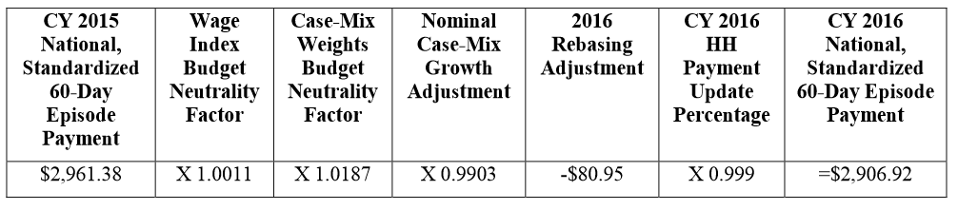
Source CMS Final Rule

CY 2016 Home Health Market Basket Update

As noted above, the ACA requires that the market basket update for HHAs be adjusted by changes in economy-wide productivity for CY 2016 (and each subsequent calendar year). The CY 2016 home health market basket (2.3 percent) adjusted for multifactor productivity or MFP (0.4 percentage points) would result in a net 1.9 percent payment update. Please also note that ACA Section 1895(b)(3)(B) requires that the home health market basket percentage increase be decreased by 2 percentage points for those HHAs that do not submit quality data as required by the Secretary.

CY 2016 Home Health Wage Index

Last year CMS proposed to change the wage index based on the newest Core Based Statistical Area (CBSA) changes for the HH PPS wage index and Office of Management and Budget (OMB) delineations, as described in OMB Bulletin No. 13-01. CMS believed that using the most recent OMB delineations will create a more accurate representation of geographic variation in wage levels. Therefore, last year the changes included a wage index using a blended wage index for a 1-year transition. CMS referred to this blended wage index as the CY 2015 HH PPS transition wage index. For CY 2016 CMS finalized the wage index be fully based on the revised OMB delineations adopted in CY 2015. For a complete run down county by county, see Appendix A.
CY 2016 National per Visits Rates
The national per-visit rates are used to determine Low Utilization Payment Adjustment (LUPA) rates for episodes with four or fewer visits, and are also used to compute imputed costs in outlier calculations. The per-visit rates are paid by either the type of visit or the home health discipline. They include: home health aide, medical social services, occupational therapy, physical therapy, skilled nursing, and speech-language pathology.

CMS calculated the CY 2016 national per-visit rates by starting with the CY 2015 national per
-visit rates. Then they applied a wage index budget neutrality factor of 1.0010 to ensure budget neutrality for LUPA per-visit payments, and then increased each of the six per-visit rates by the maximum rebasing adjustments, and the proposed market basket update. The LUPA per-visit rates are not calculated using case-mix weights. See Table 3.

Table 3 - CY 2016 National Per-Visit Payment Amounts for HHAs That DO Submit the
Required Quality Data
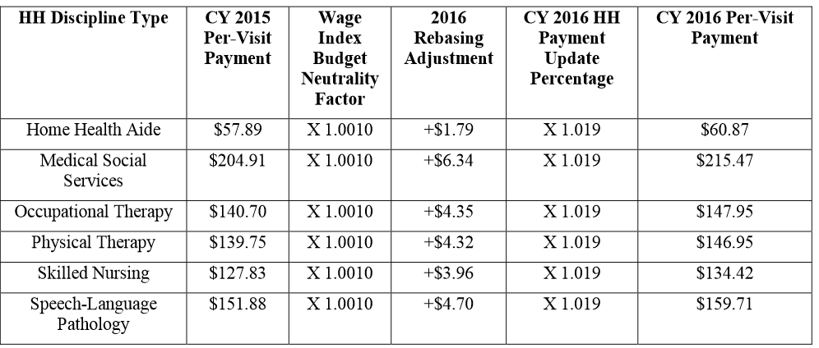
Source: CMS Final Rule

Please note the CY 2016 national per-visit rates for an HHA that does not submit the required quality data is updated by the CY 2016 HH payment update (2.3 percent) minus 2 percentage points. See Table 4.

Table 4 - CY 2016 National Per-Visit Payment Amounts for HHAs That DO NOT Submit the Required Quality Data
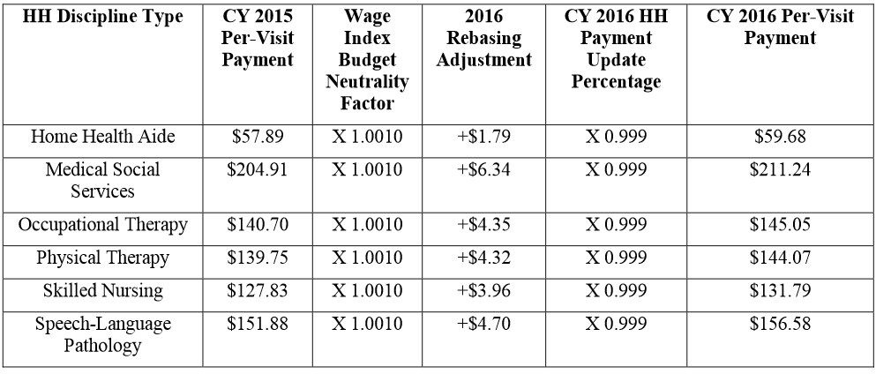
Source: CMS Final Rule

CY 2016 Low- Utilization Payment Adjustment (LUPA) Add-On Factors Remains the Same
The LUPA methodology in the final CY 2016 HH PPS rule is the same as the LUPA “add-on-factor” in the 2014 final HH PPS rule. In the CY 2014 HH PPS, CMS changed the methodology for calculating the LUPA add-on amount by finalizing the use of three LUPA add-on factors:
- 1.8451 for Skilled Nursing (SN);
- 1.6700 for Physical and Occupational Therapy (PT/OT); and
- 1.6266 for Speech Language Pathology (SLP).

CMS then multiplied the per-visit amount for the first SN, PT, OT or SLP visit in a LUPA episode that occurs as the only episode in a sequence of adjacent episodes by the appropriate factor to determine the LUPA add-on payment amount. For instance, for a LUPA episode that occurs as the only episode or an initial episode in a sequence of adjacent episodes, if the first skilled visit is SN, the payment for that visit would be $248.90 (1.8451 multiplied by $134.90), subject to the area wage adjustment. The LUPA per-visit rates are not calculated using case-mix weights.

CY 2016 Non-Routine Supply (NRS) Payment Rates
CMS determined the final CY 2016 NRS conversion factor by starting with the 2015 NRS conversion factor of $53.23 and applying the negative 2.82 percent rebasing adjustments in this year’s final rule. CMS then updates the conversion factor by the CY 2016 HH payment update of 1.9 percent for HHAs that submit the required quality data and by -0.1 percent for HHAs that do not submit quality data.
The proposed NRS conversion factor is shown in Table 5 -6 for those HHAs who submit the required quality data and in Table 7 for those HHAs that do NOT submit the required quality data.

Table 5 - CY 2016 NRS Conversion Factor for HHAs that DO Submit the Required
Quality Data
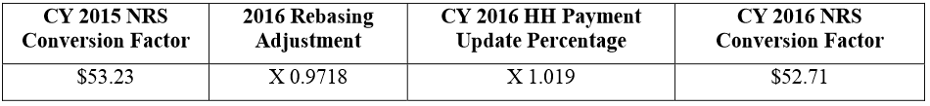
Source CMS Final Rule

Table 6 - CY 2016 NRS Conversion Factor for HHAs that DO Submit the Required Quality Data
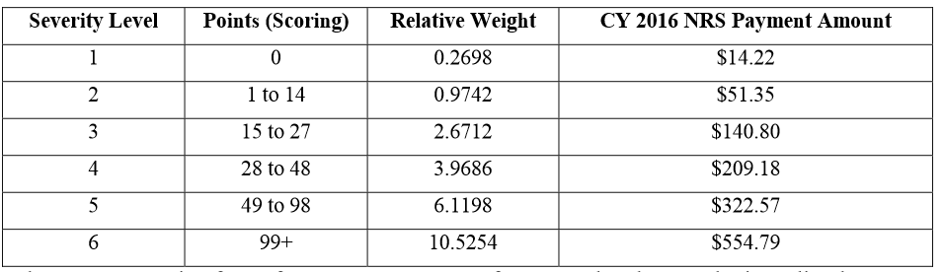
Source CMS Final Rule

Table 7 - CY 2016 NRS Conversion Factor for HHAs that DO NOT Submit the Required
Quality Data
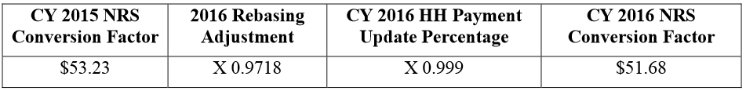
Source CMS Final Rule

CY 2016 Rural Add-On Extended
Section 3131 (c) of the ACA and amended section 421 (a) of the Medicare Modernization Act mandated a 3 percent add-on to payment amounts for HH services furnished in a rural area for episodes and visits ending on or after April 1, 2010 and before January 1, 2016. This has been extended for HH services provided in a rural area for episodes and visits ending before January 1, 2018.

Table 7 and Table 8 shows the final payment amount in rural areas.

Table 7 - CY 2016 Payment Amounts for 60-Day Episodes for Services Provided in a
Rural Area
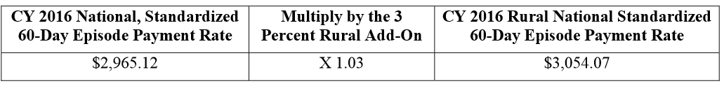
Source CMS Final Rule

Table 8 - CY 2016 Per-Visit Amounts for Services Provided in a Rural Area, Before Wage Index Adjustments for HHAs that DO Submit Quality Data
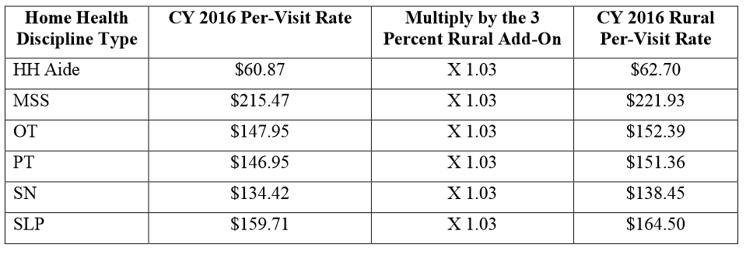
Source CMS Final Rule

Payments for High-Cost Outliers under the HH PPS/ Fixed Dollar Loss (FDL) Ratio and Loss Sharing Ratio

CMS continues their policy first implemented in CY 2011 by targeting up to 2.5 percent of estimated total payments to be paid as outlier payments and then applying the 10 percent agency-level outlier cap. The 10 percent cap is a result of excessive growth in outlier payments, primarily the result of unusually high outlier payments in a few areas of the country.

In the final rule CMS continues the Fixed Dollar Loss (FDL) ratio at the same amount of 0.45 and a loss-sharing ratio of 0.80. CMS believes this is appropriate given the percentage of estimated outlier payments.

Finalized the Technical Regulation Text Changes

CMS finalized several technical corrections in 42 CFR parts 409, 424, and 484, to better align the payment requirements with recent statutory and regulatory changes for home health services. The sections include §§ 409.43(e), 424.22(a), 484.205(d), 484.205(e), 484.220, 484.225, 484.230, 484.240(b), 484.240(e), 484.240(f), 484.245. Some of the highlights are:

- Revised § 484. 205(e) to state that estimated total outlier payments for a given calendar year are limited to no more than 2.5 percent of total outlays under the HH PPS, rather than 5 percent of total outlays, as required by section 1895(b)(5)(A) of the Act and as amended by section 3131(b)(2)(B) of the Affordable Care Act.
- Similarly, CMS specified in § 484.240(e) that the fixed dollar loss and the loss sharing amounts are chosen so that the estimated total outlier payment is no more than 2.5 percent of total payments under the HH PPS, rather than 5 percent of total payments under the HH PPS as required by section 1895(b)(5)(A) of the Act as amended by section 3131(b)(2)(B) of the Affordable Care Act.
- CMS described in § 484.240(f) that the estimated total amount of outlier payments to an HHA in a given year may not exceed 10 percent of the estimated total payments to the specific agency under the HH PPS in a given year.
- Minor editorial change in § 484.240(b) to specify that the outlier threshold for each case-mix group is the episode payment amount for that group, or the PEP adjustment amount for the episode, plus a fixed dollar loss amount that is the same for all case-mix groups.

In addition to the revisions to the regulations pertaining to outlier payments under the HH PPS, CMS proposed amending § 409.43(e)(iii) and to add language to § 484.205(d) to clarify the frequency of review of the plan of care and the provision of Partial Episode Payments (PEP) under the HH PPS as a result of a regulatory change in § 424.22(b) that was finalized in the CY 2015 HH PPS final rule (79 FR 66032).

The specifics outcome are:
- Changed the definition of an intervening event to include transfers and instances where a patient is discharged and goes to a new HHA during a 60-day episode, rather than a discharge and return to the same HHA during a 60-day episode.
- § 484.220, updated the regulations text to reflect the downward adjustments to the 60-day episode payment rate due to changes in the coding or classification of different units of service that do not reflect real changes in case-mix (nominal case-mix growth) applied to calendar years 2012 and 2013, which were finalized in the CY 2012 HH PPS final rule (76 FR 68532). This also includes updating the CY 2011 adjustment to 3.79 percent as finalized in the CY 2011 HH PPS final rule (75 FR 70461).
- § 484.225, eliminated references to outdated market basket index factors by removing paragraphs (b), (c), (d), (e), (f) and (g).
- § 484.230, delete the last sentence as a result of a change from a separate LUPA add-on amount to a LUPA add-on factor finalized in the CY 2014 HH PPS final rule (78 FR 72256).
- Deleted and reserved § 484.245, CMS believes the language is no longer applicable under HH PPS.
Finalized Home Health Value-Based Purchasing (HH VBP) Model

Background – Last year CMS proposed to implement a VBP model for HHAs similar to what was implemented for SNFs. The intent of the HH VBP was to tie a provider’s payment to its performance in such a way as to reduce inappropriate or poorly furnished care and to reward those providers who provide quality care. Section 3006(b) (1) of the ACA directs the Secretary to develop a plan to implement such a program.

The CY 2015 proposed rule mentioned the hospital-based VBP where 1.25 percent of hospital payments in 2014 were tied to the quality of care that hospitals provide. In the President’s 2015 Budget he proposes VBP should be extended to additional providers including SNFs, HHAs, ambulatory surgical centers, and hospital outpatient departments.

Last year CMS asked for comments and feedback on the elements of the HHA VBP model, size of the payment incentives and percentage of payments that would need to be placed at risk in order to encourage HHAs to make the investments to improve the quality of care and the best approach for selecting states for this pilot and put forth the following limited information:

- HHA VBP model would reduce or increase Medicare payments, in a 5-8% percent range, depending on the degree of quality performance;
- The model would apply to ALL HHAs in each of the projected five to eight states;
- The distribution of payments would be based on quality performance; and
- CMS believes the payment adjustment at risk will provide incentives to HHAs for improved planning, coordination, and management of care.

The specific goals outlined in this years’ proposed rule are:
1. Incentivize HHAs to provide better quality care with greater efficiency;
2. Study new potential quality and efficiency measures for appropriateness in the home health setting; and,
3. Enhance current public reporting processes.

CMS will be moving forward with the HH VBP in nine states. It would be mandatory for all HHAs in those states that participate; New York is not one of the states. The states that are impacted include: Massachusetts, Maryland, North Carolina, Florida, Washington, Arizona, Iowa, Nebraska, and Tennessee. Each of the 50 states was assigned to nine geographic groups; New York was assigned to Group Two along with Delaware, New Jersey, Maryland, and Pennsylvania. This group was earmarked as tending to have larger HHAs, lower utilization, and providing care to an average number of duals.

The defined population would include all Medicare beneficiaries being provided care by any Medicare-certified HHA delivering care within the selected states. LeadingAge NY discussed the high payment adjustments with other state affiliates and we are pleased that CMS addressed this by reducing the maximum penalty under the program to 3% instead of 5%. In the HH VBP there would be a maximum payment adjustment of 3% upward or downward in 2018; a maximum payment adjustment of 5% upward or downward in 2019; a maximum payment adjustment of 6% upward or downward in 2020; a maximum payment adjustment of 7% upward or downward in 2021; and a maximum payment adjustment of 8% upward or downward in 2022.Those HHAs in the nine states would have their Medicare payments tied to quality performance under the new proposed value-based purchasing model. The model will run from Jan. 1, 2016 through Dec. 31, 2022.

CMS proposed measures that have a high impact on care delivery and support improved outcomes, quality, safety, efficiency and the experience of care for the patient. The measures would be predominantly drawn from the OASIS. CMS proposed outcome and process measures that have the potential to follow patients across multiple settings. CMS had proposed 10 process measures and 15 outcome measures, plus four New Measures. The new measures that had been proposed were:
- Advance Care Planning;
- Adverse Event for Improper Medication Administration and/or Side Effects;
- Influenza Vaccination Coverage for Home Health Care Personnel; and,
- Herpes Zoster (Shingles) Vaccination received by HHA patients.
CMS finalized the set of measures by reducing the process measures to six, keeping the outcome measures to 15 and reducing the new measures to three. One new measure for Adverse Event for Improper Medication Administration and/or Side Effects was ultimately eliminated.

It is important to note that with the passage of the IMPACT Act of 2014, which mandates the collection and use of standardized post-acute care assessment data, CMS will consider proposing in future rulemaking to adopt measures that meet the requirements of the IMPACT Act as soon as they became available. Provisions of the IMPACT ACT applicable to HHAs will take effect beginning CY 2017.

Finalization of the Evaluation of the HH VBP - CMS had proposed to codify in 484.315(c) that HHAs in the nine mandatory states would be required to collect and report information to CMS necessary for the purpose of monitoring and evaluating the HH VBP model. The focus would be primarily on understanding how successful the model is in achieving quality improvement as evidenced by HHAs’ performance on clinical care process measures, clinical outcome measures, utilization/outcome measures (for example, hospital readmission rates, emergency room visits), access to care, and patient’s experience of care, and Medicare costs. CMS stated they would watch for unintended consequences.

CMS has clarified an independent evaluation is planned. They will use a multi-tiered approach by conducting the analyses at the state, HHA, and patient levels. They stated they will examine the likelihood of unintended consequences. CMS is still finalizing the evaluation process so more information will be forthcoming.

Home Health Care Quality Reporting Program (HH QRP)

In Section 2(a) of the Improving Medicare Post-Acute Care Transformation Act of 2014 (the IMPACT Act) amended Title XVIII of the Act, in part, by adding a new section 1899B, which imposes new data reporting requirements for certain post-acute care (PAC) providers, including HHAs.

CMS did finalize one standardized cross-setting measure for CY 2016 under skin integrity and changes to skin integrity domain. Measures for the other domains will be addressed through future rulemaking, although CMS is seeking feedback on four future, cross-setting measure constructs to potentially meet requirements of the IMPACT Act specified domains of:

- All-condition risk-adjusted potentially preventable hospital readmission rates;
- Resource use, including total estimated Medicare spending per beneficiary;
- Discharge to the community; and
- Medication reconciliation.

Form, Manner, and Timing of OASIS Data Submission

Background - The HH conditions of participation (CoPs) at § 484.55(d) require that the comprehensive assessment must be updated and revised (including the administration of the OASIS) no less frequently than: (1) The last 5 days of every 60 days beginning with the start of care date, unless there is a beneficiary-elected transfer, significant change in condition, or discharge and return to the same HHA during the 60-day episode; (2) Within 48 hours of the patient's return to the home from a hospital admission of 24-hours or more for any reason other than diagnostic tests; and (3) At discharge.

It is important to note that to calculate quality measures from OASIS data, there must be a complete quality episode, which requires both a Start of Care (initial assessment) or Resumption of Care OASIS assessment and a Transfer or Discharge OASIS assessment. Failure to submit sufficient OASIS assessments to allow calculation of quality measures, including transfer and discharge assessments, is a failure to comply with the CoPs. CMS plans to continue to reduce home health payment rates for HHAs that do not report OASIS quality data.

Last year, CMS reported information on a February 2012 study performed by the Department of Health and Human Services, Office of the Inspector General (OIG) to: (1) Determine the extent to which HHAs met federal reporting requirements for the OASIS data; (2) To determine the extent to which states met federal reporting requirements for OASIS data; and (3) To determine the extent to which CMS was overseeing the accuracy and completeness of OASIS data submitted by HHAs. As previously reported the home health market basket percentage increase may be reduced by two percent if a HHA does not submit the OASIS data. As noted, last year CMS finalized the proposal to define the quantity of OASIS assessments each HHA must submit to meet the pay-for-reporting requirement.

The performance system is based on the principle that each HHA is expected to submit a set of “two matching assessments” for each patient admitted to the HHA. These matching assessments together create what is considered a quality episode of care, consisting ideally of a Start of Care (SOC) or Resumption of Care (ROC) assessment and a matching End of Care (EOC) assessment.

However, CMS determined that there are several scenarios that could meet this matching assessment requirement of the new pay-for-reporting performance requirement. These scenarios of quality assessments are defined as assessments that create a quality episode of care during the reporting period or could create a quality episode if the reporting period were expanded to an earlier reporting period or into the next reporting period. According to CMS the following seven types of assessments submitted by a HHA fit this definition of a quality assessment:

- A Start of Care (SOC) or Resumption of Care (ROC) assessment that can be matched to an End of Care (EOC) assessment. These SOC/ROC assessments are the first assessment in the pair of assessments that create a standard quality of care episode described above.
- An End of Care (EOC) assessment that can be matched to a Start of Care (SOC) or
Resumption of Care (ROC) assessment.
- A SOC/ROC assessment that could begin an episode of care, but the assessment
occurs in the last 60 days of the performance period.
- An EOC assessment that could end an episode of care that began in the previous
reporting period, (that is, an EOC that occurs in the first 60 days of the performance period). This is labeled as an Early EOC quality assessment.
- A SOC/ROC assessment that is followed by one or more follow-up assessments, the
last of which occurs in the last 60 days of the performance period.
- An EOC assessment is preceded by one or more follow-up assessments, the first of
which occurs in the first 60 days of the performance period. This is labeled an EOC Pseudo Episode quality assessment.
- A SOC/ROC assessment that is part of a known one-visit episode. This is labeled as a
One -Visit episode quality assessment.

SOC, ROC, and EOC assessments that do not meet any of these definitions are labeled as
Non-Quality assessments.

Compliance with this performance requirement can be measured through the use of a direct
mathematical formula. This pay-for-reporting performance requirement metric
has been titled as the “Quality Assessments Only” (QAO) formula because only those OASIS
assessments that contribute, or could contribute, to creating a quality episode of care are included
in the computation.

The formula based on this definition is QAO = (# of Quality Assessments) divided by (# of Quality Assessments plus # of Nonquality Assessments).

CMS’s ultimate goal is to require all HHAs to achieve a pay-for-reporting performance
requirement compliance rate of 90 percent or more, as calculated using the QAO metric
mentioned above.

CMS plans to follow the pay-for-reporting requirements of:

- Assessments submitted on or after July 1, 2015 and before June 30, 2016 with appropriate start of care dates, HHAs must score at least 70 percent on the QAO metric of pay-for-reporting performance requirement or be subject to a 2 percentage point reduction to their market basket update for CY 2017.
- CMS had asked for public feedback on the performance threshold at 80 percent for the reporting period from July 1, 2016 through June 30, 2017 or be subject to a 2 percentage point reduction to their market basket update for CY 2018.
- For the reporting period from July1, 2017 through June 30, 2018 and thereafter, CMS had proposed the performance threshold would be 90 percent or be subject to a 2 percentage point reduction to their market basket update for CY 2019.

CMS states that during this initial performance period for the pay-for-reporting performance requirement would be July 1, 2015 through June 30, 2016 and they held Open Door Forums to educate HHA personnel as needed about:
- The pay-for-reporting performance requirement program; and
- The pay-for-reporting performance QAO metric.

CMS will distribute individual provider preview reports and has posted a report which provides a detailed explanation of the methodology.

CMS has finalized adopting the 80 percent for the Pay for Reporting Performance Requirement for Submission of OASIS Quality Data for Year Two reporting period from July 1, 2016 through June 30, 2017 or be subject to a 2 percentage point reduction to their market basket update for CY 2018. They also finalized the reporting period from July1, 2017 through June 30, 2018 and thereafter, at a 90 percent Pay for Reporting Performance Requirement for Submission of OASIS Quality Data or be subject to a 2 percentage point reduction to their market basket update for CY 2019.

Home Health Care CAHPS Survey (HHCAHPS)

CMS continues with the policy from the CY 2015 HH PPS Final Rule requiring that the home health quality measures reporting requirements for Medicare-certified agencies include the Home Health Care CAHPS® (HHCAHPS) Survey for the CY 2016 Annual Payment Update (APU).

CMS has previously stated that Medicare-certified HHAs are required to contract with an
approved HHCAHPS survey vendor. This requirement continues, and Medicare-certified
agencies also must provide on a monthly basis a list of all their survey-eligible home health care
patients to their vendors.

Please note the submission dates for the HHCAHPS through CY 2018. HHAs are required to submit their HHCAHPS data files to the HHCAHPS Data Center for the HHCAHPS data for specific time periods. The deadlines are firm; no exceptions are permitted.

CMS did not make any changes to the HHCAHPS requirements, they only updated the information to reflect the dates in the future APU years.

Conclusion

The final rule focuses on many of the same areas of HH PPS as before; case-mix weights, non-routine medical supplies (NRS), home health market basket, per-visit payment rates. The overall increase in payments was lowered to $260 million nationally and we remain concerned about the fiscal health of our HHAs. The pressures mount on both the Federal and State levels. For example, the Governor recently vetoed our proposed legislation (S.5878/A.8171) entitled, "AN ACT to amend the public health law, in relation to rebasing of the episodic reimbursement methodology for certified home health agencies" which sought to limit Medicaid cuts as a result of rebasing of the CHHA Episodic Payment System (EPS) to levels passed in this year’s state budget.

LeadingAge NY will be closely monitoring the HH VBP model and the impact it will have on the HHAs in the nine pilot states for lessons to be learned for New York. Of concern are any unintended consequences and any negative impacts to rural HHAs and their patients. Of course, the HH VBP model could have a significant fiscal impact on some HHAs. We will be working closely with LeadingAge national as the demonstration program evolves.

For any additional comments or questions regarding the CY 2016 HH PPS final rule, please contact Cheryl Udell at cudell@leadingageny.org or at 518-867-8871.

Appendix A:

