13 British American Blvd., Suite 2, Latham, New York 12110 Telephone (518) 867-8383 Web www.leadingageny.org

M E M O R A N D U M
TO: | Community Services Members
FROM: | Cheryl Udell, Community Services Policy Analyst
DATE: | July 19, 2016
SUBJECT: | Home Health Agency Proposed Medicare Rule for 2017
ROUTE TO: | Administrator/Director, CFO

ABSTRACT: CMS releases HHA PPS proposed rule for CY 2017.

Introduction

The Centers for Medicare and Medicaid Services (CMS) has issued the Medicare Home Health Prospective Payment System (HH PPS) proposed rule for Calendar Year (CY) 2017. The complete rule is published in the Federal Register. The final rule will likely be issued sometime in the last quarter of 2017.

Public comments on the proposed changes must be received by CMS by 5 p.m., Sept. 5, 2016. Comments should reference file code CMS-1648-P and may be submitted electronically at http://www.regulations.gov by following the instructions under More Search Options.

For additional details on submitting comments please refer to the Federal Register link referenced above for detailed instructions.

CMS estimates that approximately 3.5 million beneficiaries receive home health services from nearly 11,850 home health agencies (HHAs), costing Medicare approximately $17.9 billion.

Overall Impact and Summary of Key Provisions

CMS is proposing measures that equal a 1.0 percent decrease in total Medicare payments to HHAs for CY 2017. Nationally, total Medicare revenue would be reduced by approximately $180 million. This is different from last year’s final HH PPS reduction of 1.4% or $260 million.
CMS continues implementing the fourth and final year phase-in of the rebasing adjustments to the national, standardized 60-day episode payment amount, the national per-visit rates and the NRS conversion factor. The rebasing adjustments for CY 2017 would:
- continue to reduce the national, standardized 60-day episode payment amount by $80.95;
- increase the national per-visit payment amounts by 3.5 percent of the national per-visit payment amounts in CY 2010 with the increases ranging from $1.79 for home health aide services to $6.34 for medical social services; and
- reduce the NRS conversion factor by 2.82 percent.
CMS is also proposing to make changes to the outlier payment methodology and the fixed dollar loss (FDL) ratio and has asked for comments on both. In addition, CMS is proposing several changes to the Home Health Value-Based Purchasing (HH VBP) model. In last year’s HH PPS there was an extensive section on the HH VBP model that was implemented earlier this year. As we reported, Medicare-certified HHAs selected for inclusion in the HH VBP model would be required to compete for payment adjustments to their current PPS reimbursements based on quality performance. New York is NOT one of the nine states selected, but a careful review of the proposed changes is warranted because of the potential impact it could have on New York going forward.
In the proposed rule there are suggested payment policies for negative pressure wound therapy (NPWT) performed using a disposable device for patients being served by HHAs.
Other proposals include the Improving Medicare Post-Acute Care Transformation Act of 2014 (the IMPACT Act) that requires HHAs to submit standardized patient assessment data, as well as standardized data on quality measures and resource use, and other measures. The IMPACT Act requires collection across eight domains. In the proposed rule, CMS is adopting four new payment determination measures for 2018 to meet the IMPACT Act requirements. The measures are preventable hospital readmission rates, total estimated Medicare spending per patient, discharge to the community and medication reconciliation.
This proposed rule also includes changes to the home health quality reporting program (HH QRP).
In the CY 2015 proposed rule, the Face-to-Face (F2F) requirement was extensively covered with several proposals to reduce the burden to home health agencies (HHAs) and physicians, and to mitigate instances where physicians and HHAs unintentionally fail to comply with certification requirements. For the last two years there has been no mention of the F2F requirement in the proposed or final HH PPS.

Proposed HH PPS in Greater Detail

Rebasing

The Affordable Care Act (ACA) required that beginning in CY 2014, CMS apply an adjustment to the national standardized 60-day episode rate and other applicable amounts to reflect factors such as changes in the number of visits in an episode, the mix of services in an episode, the level of intensity of services in an episode, the average cost of providing care per episode, and other relevant factors. Additionally, CMS must phase-in any adjustment over a four-year period, in equal increments, not to exceed 3.5 percent of the amount (or amounts) in any given year, and be fully implemented by CY 2017. CY 2017 will the fourth and final year for rebasing adjustments to the HH PPS payment rates.

CMS continues to monitor potential impacts of rebasing. They stated that a 3.45 percent adjustment for CY 2014 through CY 2017 would result in larger dollar amount reductions than the maximum dollar amount allowed under the Affordable Care Act. The statute specifies that the maximum rebasing adjustment is to be no more than 3.5 percent based on the CY 2010 rates, not the CY 2013 rates. Therefore, in the CY 2014 HH PPS final rule for each year, CY 2014 through CY 2017, they finalized a fixed dollar reduction to the national, standardized 60-day episode payment rate of $80.95 per year.

Note this reduction to the national, standardized 60-day episode payment rate of $80.95 per year along with a proposed 0.97 percent reduction to the national, standardized 60-day episode payment rate in CY 2017 to account for estimated case-mix growth unrelated to increases in patient acuity is another hit to home care.

CY 2017 HH PPS Case-Mix Weights

To recalibrate the HH PPS case-mix weights for CY 2017, CMS proposes to use the same methodology finalized in past HH PPS rules, including the CY 2008, CY 2012 and the CY 2015 HH PPS final rule. Annual recalibration of the HH PPS case-mix weights ensures that the case-mix weights reflect, as accurately as possible, current home health resource use and changes in utilization patterns. To generate the proposed CY 2017 HH PPS case-mix weights, CMS used CY 2015 home health claims data (as of Dec. 31, 2015) with linked OASIS data. They will use CY 2015 home health claims data (as of June 30, 2016) with linked OASIS data to generate the CY 2017 HH PPS case-mix weights in the CY 2017 HH PPS final rule.

To ensure the changes to case-mix weights are implemented in a budget-neutral manner, CMS would apply a case-mix budget neutrality factor for CY 2017 of 1.0062 to the national, standardized 60-day episodic payment rate.

See Appendix A for the CY 2017 Proposed Case-Mix Weights.

CY 2017 Home Health Market Basket Update

The ACA requires that the market basket update for HHAs be adjusted by changes in economy-wide productivity for CY 2017 (and each subsequent calendar year). Therefore, the current estimate of the CY 2017 home health market basket is 2.3 percent (2.8 percent adjusted for multifactor productivity), or MFP (0.5 percentage points) would result in a 2.3 percent payment update.

As a reminder, the ACA Section 1895(b)(3)(B) requires that the home health market basket percentage increase be decreased by 2 percentage points for those HHAs that do not submit quality data as required by the Secretary.

CY 2017 Home Health Wage Index
In 2015, CMS proposed and finalized changes to the wage index based on the newest Core Based Statistical Area (CBSA) changes for the HH PPS wage index and Office of Management and Budget (OMB) delineations, as described in OMB Bulletin No. 13-01. CMS believed that using the most recent OMB delineations would create a more accurate representation of geographic variation in wage levels. Therefore, in CY 2016, CMS finalized the wage index to be fully based on the revised OMB delineations adopted in CY 2015.
See Appendix B for the Proposed CY 2017 Wage Index.

Reduction to the National, Standardized 60-Day Episode Payment Rate
CMS proposes a CY 2017 national, standardized 60-day episode payment rate based upon the CY 2016 standardized 60-day episodic payment, applying an average wage index standardization factor, a case-mix budget neutrality factor, a reduction of 0.97 percent to account for nominal case-mix growth from 2012 to 2014, the rebasing adjustment, and then the MFP-adjusted home health market basket update.
CMS explained that to calculate the wage index standardization factor, commonly referred to as the wage index budget neutrality factor, they simulated total payments for non-LUPA episodes using the proposed CY 2017 wage index and compared it to their simulation of total payments for non-LUPA episodes using the CY 2016 wage index. They then divided the total payments for non-LUPA episodes using the proposed CY 2017 wage index by the total payments for non-LUPA episodes using the CY 2016 wage index and obtained a wage index budget neutrality factor of 0.9990. That is how they arrived at the wage index budget neutrality factor of 0.9990 to the proposed CY 2017 national, standardized 60-day episode rate.
The proposed national, standardized 60-day episode payment for CY 2017 is $2,936.68. See Table 1.

Table 1 – Proposed CY 2017 60-Day National, Standardized 60-Day Episode Payment Amount
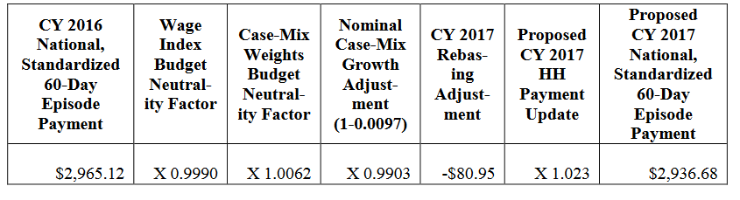
Source: CMS
CY 2017 National Per-Visit Rates
The national per-visit rates are used to pay LUPAs (episodes with four or fewer visits)
and are also used to compute imputed costs in outlier calculations. The per-visit rates are paid by either the type of visit or the home health discipline. They include: home health aide, medical social services, occupational therapy, physical therapy, skilled nursing, and speech-language pathology.

CMS calculated the CY 2017 national per-visit rates by starting with the CY 2016 national per
-visit rates. Then they applied a wage index budget neutrality factor of 0.9998 to ensure budget neutrality for LUPA per-visit payments, and then increased each of the six per-visit rates by the maximum rebasing adjustments, and the proposed market basket update. The LUPA per-visit rates are not calculated using case-mix weights. See Table 2.

Table 2 – Proposed CY 2017 National Per-Visit Payment Amounts for HHAs That DO Submit the Required Quality Data
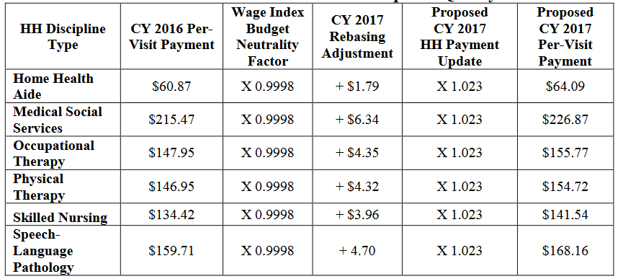
Source: CMS

Please note the CY 2017 national per-visit rate for an HHA that does not submit the required quality data is updated by the CY 2017 HH payment update (2.3 percent) minus 2 percentage points. See Table 3.

Table 3 – Proposed CY 2017 National Per-Visit Payment Amounts for HHAs That DO NOT Submit the Required Quality Data
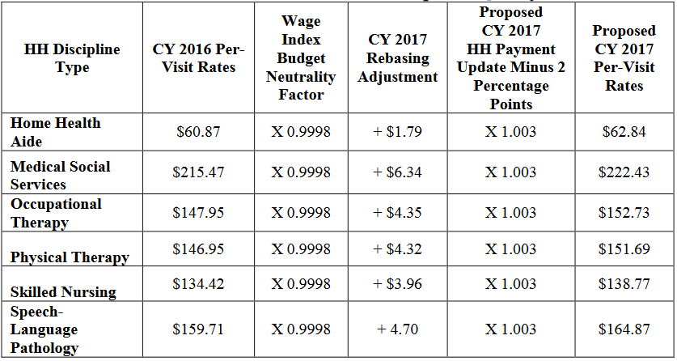
Source: CMS
CY 2017 Low- Utilization Payment Adjustment (LUPA) Add-On Factors
The Low-Utilization Payment Adjustment (LUPA) in the proposed CY 2017 HH PPS is the same as the LUPA “add-on factor” in the 2014 final HH PPS rule. In the CY 2014 HH PPS, CMS changed the methodology for calculating the LUPA add-on amount by finalizing the use of three LUPA add-on factors:
- 1.8451 for Skilled Nursing (SN);
- 1.6700 for Physical and Occupational Therapy (PT/OT); and
- 1.6266 for Speech Language Pathology (SLP).

CMS then multiplied the per-visit amount for the first SN, PT, OT or SLP visit in a LUPA episode that occurs as the only episode in a sequence of adjacent episodes by the appropriate factor to determine the LUPA add-on payment amount. For instance, for a LUPA episode that occurs as the only episode or an initial episode in a sequence of adjacent episodes, if the first skilled visit is SN, the payment for that visit would be $261.16 (1.8451 multiplied by $141.54), subject to the area wage adjustment. The LUPA per-visit rates are not calculated using case-mix weights.

CY 2017 Non-Routine Medical Supply (NRS) Payment Rates
CMS determined the proposed CY 2017 NRS conversion factor by starting with the 2016 NRS conversion factor of $52.71, applying the -2.82 percent rebasing adjustments, and then updating the conversion factor by the CY 2016 HH payment update of 2.3 percent. The proposed NRS conversion factor is shown in Table 4 for those HHAs who submit the required quality data. Using the CY 2015 NRS conversion factor, the payment amounts for the six severity levels are in Table 5.

Table 4 – Proposed CY 2017 NRS Conversion Factor for HHAs that DO Submit the Required Quality Data
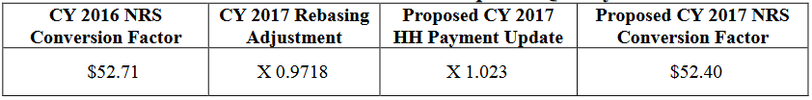
Source: CMS

Table 5 – Proposed CY 2017 NRS Conversion Factor for HHAs that DO Submit the Required Quality Data
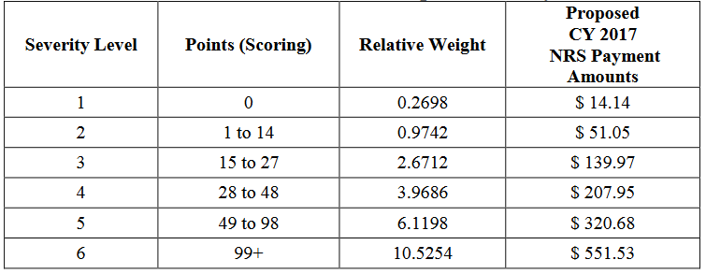
Source: CMS

CY 2017 Rural Add-On Extended
Section 3131 (c) of the ACA amended section 421 (a) of the Medicare Modernization Act to provide an increase of 3 percent of the payment amount for HH services furnished in a rural area for episodes and visits ending on or after April 1, 2010 and before Jan. 1, 2016. This has been extended for HH services provided in a rural area for episodes and visits ending before Jan. 1, 2018.

Tables 6 and 7 show the proposed payment amount in rural areas.

Table 6 – Proposed CY 2017 Payment Amounts for 60-Day Episodes for Services Provided in a Rural Area
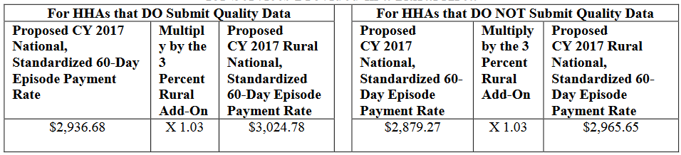
Source: CMS

Table 7 – Proposed CY 2017 Per-Visit Amounts for Services Provided in a Rural Area
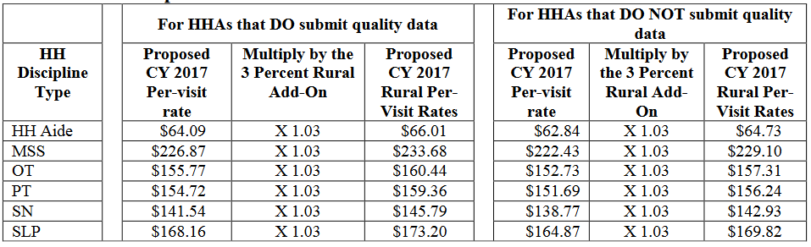
Source: CMS

Two Proposed CY 2017 Payment Changes for High-Cost Outliers

In the past, CMS targeted up to 2.5 percent of estimated total payments to be paid as outlier payments and then applied the 10 percent agency-level outlier cap. The 10 percent cap was a result of excessive growth in outlier payments, primarily the result of unusually high outlier payments in a few areas of the country. Now CMS is proposing several changes.

CMS analyzed CY 2015 home health claims data and found that there is significant variation in the visit length by discipline for outlier episodes. HHAs with 10 percent of their total payments as outlier payments were providing shorter but more frequent skilled nursing visits than HHAs with less than 10 percent of their total payments as outlier payments. See Table 8.

Table 8 – Average Number and Length of Skilled Nursing Visits by the Percentage of
Outlier Payments to Total Payments at the Agency Level (Current Outlier Methodology), CY 2015
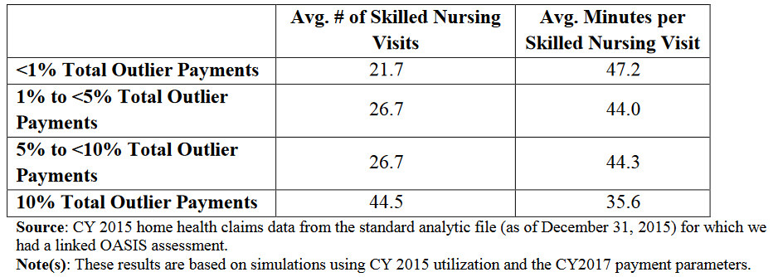

CMS continued their analysis and found the number of skilled nursing visits was significantly higher than the number of visits for the five other disciplines of care. They concluded, therefore, that outlier payments are predominately driven by the provision of skilled nursing services. See Table 9.

Table 9 – Average Number of Visits by Discipline for Outlier Episodes
Discipline | Average Number of Visits
Home health aide | 8.8
Medical social services | 0.3
Occupational therapy | 2.3
Physical therapy | 5.1
Skilled nursing | 34.0
Speech-language pathology | 0.7
Source: Same as Table 8

According to CMS, as a result of the analysis of CY 2015 home health claims data, the “current methodology for calculating outlier payments may create a financial disincentive for providers to treat medically complex beneficiaries who require longer visits.” Therefore, the first change CMS is proposing is to change the methodology used to calculate outlier payments, using a cost-per-unit approach rather than a cost-per-visit approach. They are suggesting to convert the national per-visit rates into per 15-minute unit rates. The new per-unit rate by discipline would then be used, along with visit length data by discipline reported on the home health claim in 15-minute increments. CMS stated that the change in methodology would be budget neutral and they would still target to pay out 2.5 percent of total payments as outlier payments. See Table 10.

Table 10 – Proposed Cost-Per-Unit Payment Rates for the Calculation of the Outlier Payments
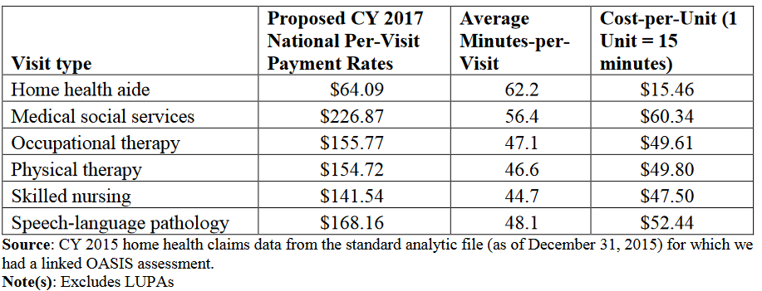

CMS thinks this change in approach will result in more accurate outlier payments where the calculated cost per episode accounts not only for the number of visits during an episode, but also the length of the visit. In the proposed rule CMS stated, “This, in turn, may address some of the findings from the home health study, where margins were lower for patients with medically complex needs that typically require longer visits, thus potentially creating an incentive to treat less complex patients.”

CMS included two additional tables for review. Table 11 shows the average number of visits and the visit length for the episodes that would receive outlier payments under the current cost-per-visit approach, but not under the proposed cost-per-visit approach. They also show the average number of visits and the visit length for the episodes that would receive outlier payments under the proposed cost-per-unit approach, but not under the current cost-per-visit approach.

Table 11 – Average Number of Visits and Visit Length for Episodes that Receive Outlier Payments Only Under the Current Outlier Methodology and for Episodes that Receive Outlier Payments Only Under the PROPOSED Outlier Methodology, CY 2015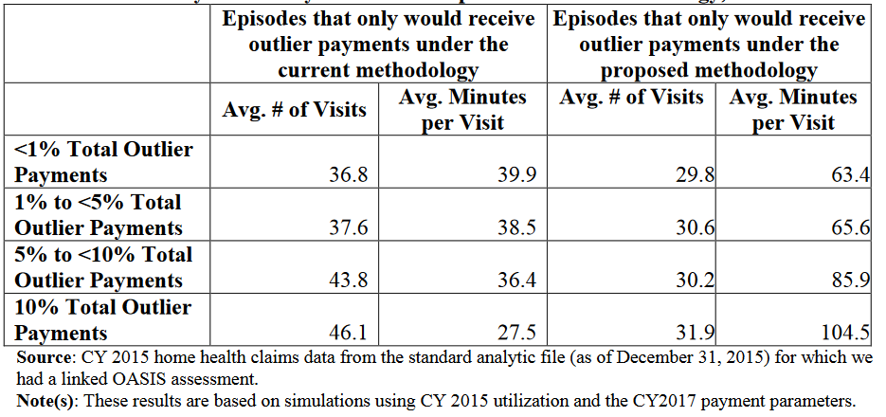
CMS continued their analysis by examining the potential impact from changing the methodology from the current cost-per-visit to the proposed cost-per-unit on a subset of vulnerable patient populations. See Table 12.

Table 12 – Impact of the Proposed Outlier Methodology Change on Subgroups of
Vulnerable Patient Populations Identified in the Home Health Study
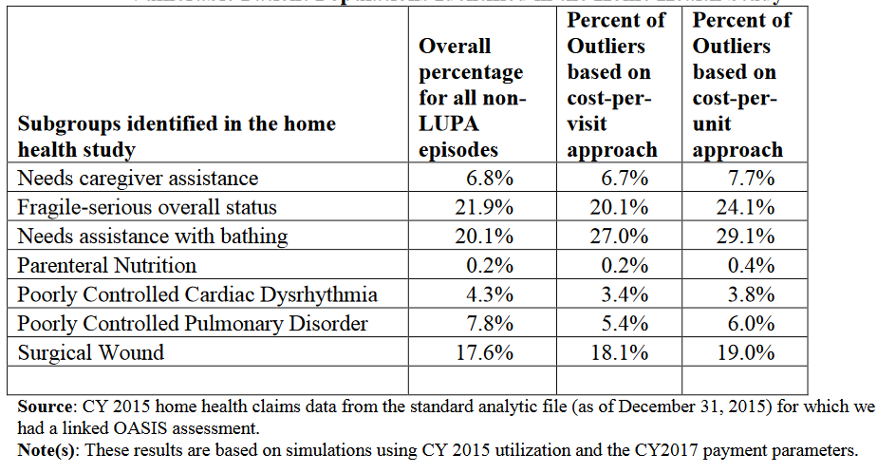
CMS thinks these results suggest that the proposed change to the outlier methodology may address some of the findings from the home health study and may alleviate potential financial disincentives to treat patients with medically complex needs.

The second change CMS is proposing is to implement a cap on the amount of time per day that would be counted toward the estimation of an episode’s costs for outlier calculation purposes. They are proposing to limit the amount of time per day (summed across the six disciplines) to eight hours or, as proposed above, 32 units. They state this is consistent with the definition of “part-time” or “intermittent” set out in Section 1861(m) of the Act, which limits the amount of skilled nursing and home health aide minutes combined to less than eight hours each day and 28 or fewer hours each week. CMS points out that they are not limiting the amount of care that can be provided on any given day; rather, they are limiting the time per day that can be credited toward the estimated cost of an episode when determining if an episode should receive outlier payments and calculating the amount of the outlier payment.
CMS is asking for comments on these proposed changes.
Fixed Dollar Loss (FDL) Ratio and Loss-Sharing Ratio

In past rules, CMS continued the Fixed Dollar Loss (FDL) ratio at the same amount of 0.45 and a loss-sharing ratio of 0.80. CMS believed this was appropriate given that the percentage of outlier payments is estimated. Now, with the proposed outlier payment changes, CMS is proposing a different FDL ratio.

CMS states that for a given level of outlier payments, there is a trade-off between the values selected for the FDL ratio and the loss-sharing ratio. A high FDL ratio reduces the number of episodes that can receive outlier payments, but makes it possible to select a higher loss-sharing ratio and therefore increase outlier payments for qualifying outlier episodes. Alternatively, a
lower FDL ratio means that more episodes can qualify for outlier payments, but outlier payments per episode must then be lower.

CMS cites the statutory requirement to target up to, but no more than, 2.5 percent of total
payments as outlier payments. Therefore, they are proposing a change to the FDL ratio for CY
2017, as they believe that maintaining an FDL ratio of 0.45 with a loss-sharing ratio of 0.80 is no longer appropriate given the percentage of outlier payments projected for CY 2017.

CMS is not proposing a change to the loss-sharing ratio (0.80) in order for the HH PPS to be consistent with the payment for high cost outliers in other Medicare payment systems. Under the current outlier methodology, they are suggesting changing the FDL from 0.45 to 0.48 to pay up to, but no more than, 2.5 percent of total payments as outlier payments. Under the proposed outlier methodology, which would be cost-per-unit, they are suggesting an FDL ratio of 0.45 to 0.56 to pay up to, but no more than, 2.5 percent of total payments as outlier payments.

CMS is asking for comments on the proposed changes.

Proposed Payment Policies for Negative Pressure Wound Therapy

Negative pressure wound therapy (NPWT) is a medical procedure in which a vacuum
dressing is used to enhance and promote healing in acute, chronic, and burn wounds. The
therapy involves using a sealed wound dressing attached to a pump to create a negative
pressure environment in the wound. Applying continued or intermittent vacuum pressure helps
to increase blood flow to the area and draw out excess fluid from the wound. NPWT can be used for days or months. It can be used in a conventional system and classified as a durable medical equipment (DME), or it can be performed with a single-use disposable system that consists of a non-manual vacuum pump. The disposable systems have a preset continuous negative pressure, no intermittent setting, are pocket-sized, easily transportable, and generally are battery operated.

DMEs are considered routine or non-routine, and a disposable NPWT system would be considered a non-routine supply for home health. Patients under a home health plan of care,
payment for part-time or intermittent skilled nursing, physical therapy, speech-language
pathology, occupational therapy, medical social services, part-time or intermittent home health
aide visits, and routine and non-routine supplies are included in the episode payment amount. A
disposable NPWT system is currently considered a non-routine supply and thus payment for the
disposable NPWT system is included in the episode payment amount. It is proposed under the Consolidated Appropriations Act of 2016 (Pub. L 114-113) requiring a separate payment to an HHA for an applicable disposable device when furnished on or after Jan. 1, 2017 to an individual who receives home health services for which payment is made under the Medicare home health benefit. An applicable disposable device is defined as a disposable negative pressure wound therapy device.

As required by the Consolidated Appropriations Act of 2016, separate payment amount for NPWT using a disposable system is to be set equal to the amount of the payment that would be made under the Medicare Hospital Outpatient Prospective Payment System (OPPS) using the Level I Healthcare Common Procedure Coding System (HCPCS) code. The codes are:

HCPCS 97607 – Negative pressure wound therapy (for example, vacuum assisted drainage
collection), utilizing disposable, non-durable medical equipment including provision of
exudate management collection system, topical application(s), wound assessment, and
instructions for ongoing care, per session; total wound(s) surface area less than or
equal to 50 square centimeters.

HCPCS 97608 – Negative pressure wound therapy (for example, vacuum assisted
drainage collection), utilizing disposable, non-durable medical equipment including provision of
exudate management collection system, topical application(s), wound assessment, and
instructions for ongoing care, per session; total wound(s) surface area greater than 50 square
centimeters.

The change in payment policy CMS is proposing is that for instances where the sole purpose for an HHA visit is to furnish NPWT using a disposable device, Medicare will not pay for the visit under the HH PPS. Instead, CMS is proposing that since furnishing NPWT using a disposable device for a patient under a home health plan of care is to be paid separately based on the OPPS amount, which includes payment for both the device and furnishing the service, the HHA must bill these visits separately under type of bill 34x (used for patients not under an HH plan of care, Part B medical and other health services, and osteoporosis injections) along with the appropriate HCPCS code (97607 or 97608). Visits performed solely for the purposes of furnishing NPWT using a disposable device are not to be reported on the HH PPS claim (type of bill 32x).

CMS is asking for comments on the proposed changes.
Update on Future Plans to Group HH PPS Claims Centrally During Claims Processing
In the CY 2011 HH PPS proposed rule, CMS solicited comments on potential plans to group HH PPS claims centrally during claims processing and received many comments in support of this initiative. In grouping HH PPS Claims centrally during processing, CMS described a process whereby all of the information necessary to group the claim and assign a Health Insurance Prospective Payment System (HIPPS) score which determines payment is available and processed within the Fiscal Intermediary Shared System (FISS). After CMS conducted further analysis, they determined that the use of the treatment authorization field was not a viable option. They concluded the information they planned to report in this field was not permitted by the Health Insurance Portability Accountability Act (HIPAA).

In this proposed rule, CMS is asking for feedback on another process identified whereby all of the information necessary to group HH PPS claims occurs centrally during claims processing.

In the rule, CMS describes the current billing process. They review that Medicare makes payment under the HH PPS on the basis of a national, standardized 60-day episode payment amount that is adjusted for case-mix and geographic wage variations. The national, standardized 60-day episode payment amount includes services from the six HH disciplines (skilled nursing, HH aide, physical therapy, speech-language pathology, occupational therapy, and medical social services) and non-routine medical supplies. As we described earlier under NPWT, DMEs covered under HH is paid for outside the HH PPS payment. To adjust for case-mix, the HH PPS uses a 153-category case-mix classification to assign patients to a home health resource group (HHRG). Clinical needs, functional status, and service utilization are computed from responses to selected data elements in the Outcome & Assessment Information Set (OASIS) instrument. On Medicare claims, the HHRGs are represented as HIPPS codes.

CMS continues to find OASIS assessments submitted with erroneous HIPPS codes through a process of comparing the submitted HIPPS code to the HIPPS code returned by their assessment system. These errors may occur when HHAs or their software vendors inaccurately replicate the HH PPS Grouper algorithm into the HHA’s customized software.

CMS thinks that embedding the HH PPS Grouper within the claims processing system would mitigate the provider’s vulnerability and improve payment accuracy. They implemented a process where they match the claim and the OASIS assessment in order to validate the HIPPS code on the Medicare bill. They believe that making additional enhancements to the claim and OASIS matching process would enable them to collect all of the other necessary information to assign a HIPPS code within the claims processing system. CMS thinks that adopting this process would improve payment accuracy, decrease costs, and make it easier for HHAs.

CMS is asking for comments on the proposed change.

Proposed Changes to Home Health Value-Based Purchasing (HHVBP) Model

In the CY 2016 HH PPS final rule, CMS implemented the HHVBP Model to begin on Jan. 1, 2016. The purpose of HHVBP Model has been to improve the quality and delivery of home health care services to Medicare beneficiaries. The specific goals are to: (1) provide incentives for better quality care with greater efficiency; (2) study new potential quality and efficiency measures for appropriateness in the home health setting; and, (3) enhance the current public reporting process.

Nine states were selected for inclusion in the HHVBP Model, representing each geographic
area across the nation. All Medicare-certified HHAs that provide services in Arizona, Florida,
Iowa, Maryland, Massachusetts, Nebraska, North Carolina, Tennessee, and Washington
are required to compete in the Model. New York was NOT selected; however, this model warrants attention given the ongoing development of New York’s VBP through Medicaid.

As finalized in the CY 2016 HH PPS final rule, the HHVBP will adjust Medicare payment rates
beginning in CY 2018 based on performance on applicable measures. Payment adjustments will be increased incrementally over the course of several years.

CMS is proposing several changes to HHVBP. They include:

- Proposal to Eliminate Smaller- and Larger-Volume Cohorts Solely for Purposes of Setting Performance Benchmarks and Thresholds
The HHVBP Model compares a competing HHA’s performance on quality measures
against the performance of other competing HHAs within the same state and size cohort. CMS has continued to evaluate the calculation of the benchmarks and achievement thresholds using the most recent CY 2015 data that is now available. CMS has detailed in three tables results highlighting that there is a greater degree of interstate variation in the benchmark values for the cohorts that have fewer HHAs as compared to the variation in benchmark values for the cohorts that have a greater number of HHAs.

CMS is proposing to calculate the benchmarks and achievement thresholds at the state level rather than at the smaller- and larger-volume cohort level for all model years, beginning with CY 2016.

- The Payment Adjustment Methodology
CMS is proposing that a smaller-volume cohort have a minimum of eight HHAs in order for the HHAs in that cohort to be compared only against each other, and not against the HHAs in the larger-volume cohort. They believe this would better mitigate the impact of outliers.

- Quality Measure Proposals
CMS is reviewing and believes four measures require further consideration before inclusion in the HHVBP Model. They are proposing to remove the following measures: (1) Care Management: Types and Sources of Assistance; (2) Prior Functioning ADL/IADL; (3) Influenza Vaccine Data Collection Period; and (4) Reason Pneumococcal Vaccine Not Received.

- Public Display of Total Performance Scores
One of the goals of the HHVBP is greater transparency in the industry. Having annual public performance reports will increase transparency on Medicare data on quality and align the competitive forces within the market to deliver care based on value over volume. The reports will inform home health industry stakeholders as well as all competing HHAs delivering care to Medicare beneficiaries within selected state boundaries on their level of quality relative to both their peers and their own past performance. As CMS develops the public reporting mechanism for the HHVBP Model, they are considering which data elements reported would be meaningful. They plan on having this available beginning no earlier than CY 2019.

CMS is asking for comments on the proposed changes.

Home Health Care Quality Reporting Program (HH QRP)

Section 2(a) of the Improving Medicare Post-Acute Care Transformation Act of 2014 (the IMPACT Act) amended Title XVIII of the Act, in part, by adding a new section 1899B, which imposes new data reporting requirements for certain post-acute care (PAC) providers, including HHAs. In last year’s rule, CMS sought feedback on four cross-setting measure constructs to potentially meet requirements of the IMPACT Act domains of:

- All-condition risk-adjusted potentially preventable hospital readmission rates;
- Resource use, including total estimated Medicare spending per beneficiary;
- Discharge to the community; and
- Medication reconciliation.

In this year’s HH PPS, CMS is proposing for the CY 2018 payment determination to adopt 1000four new measures.

- Proposal to Address the IMPACT Act Domain of Resource Use and Other Measures (MSPB-PAC)
Rising Medicare expenditures for post-acute care as well as wide variation in spending for these services underlines the importance of measuring resource use for providers rendering these services. According to CMS, given the current lack of resource use measures for Post-Acute Care (PAC) settings, the proposed MSPB-PAC measure has the potential to provide valuable information to HHAs on their relative Medicare spending in delivering services to approximately 3.5 million Medicare beneficiaries.

- Discharge to the Community
This proposed measure assesses successful discharge to the community from a home health (HH) setting, with successful discharge to the community including no unplanned hospitalizations and no deaths in the 31 days following discharge from the HH agency setting. Specifically, this proposed measure reports an HHA’s risk-standardized rate of Medicare FFS patients who are discharged to the community following an HH episode, do not have an unplanned admission to an acute care hospital or LTCH in the 31 days following discharge to community, and remain alive during the 31 days following discharge to community.

- Potentially Preventable 30-Day Post-Discharge Readmission Measure for PAC
This proposed measure assesses the facility-level risk-standardized rate of unplanned, potentially preventable hospital readmissions for Medicare FFS beneficiaries that take place within 30 days of an HH discharge. The HH admission must have occurred within up to 30 days of discharge from a prior proximal hospital stay, which is defined as an inpatient admission to an acute care hospital. Hospital readmissions include readmissions to a short-stay acute-care hospital or an LTCH, with a diagnosis considered to be unplanned and potentially preventable. CMS cites in the HH PPS,
“Hospital readmissions among the Medicare population, including beneficiaries that utilize PAC, are common, costly, and often preventable. The MedPAC estimated that 17 to 20 percent of Medicare beneficiaries discharged from the hospital were readmitted within 30 days. MedPAC found that more than 75 percent of 30-day and 15-day readmissions and 84 percent of 7-day readmissions were considered ‘potentially preventable.’ In addition, MedPAC calculated that annual Medicare spending on potentially preventable readmissions would be $12 billion for 30-day, $8 billion for 15-day, and $5 billion for 7-day readmissions. For hospital readmissions from one post-acute care setting, SNFs, MedPAC deemed 76 percent of these readmissions as ‘potentially avoidable’–associated with $12 billion in Medicare expenditures. An analysis of data from a nationally representative sample of Medicare FFS beneficiaries receiving home health services in 2004 show that home health patients receive significant amounts of acute and post-acute services after discharge from home health care. Within 30 days of discharge from home health, 29 percent of patients were admitted to a hospital. The 30-day rehospitalization rate was 26 percent with the largest proportion related to a cardiac-related diagnosis (42 percent).”

- Drug Regimen Review Conducted with Follow-Up for Identified Issues-Post-Acute Care
This proposed measure assesses whether PAC providers were responsive to potential or actual clinically significant medication issue(s) when such issues were identified. Specifically, the proposed quality measure reports the percentage of patient episodes in which a drug regimen review was conducted at the start of care or resumption of care and that timely follow-up with a physician occurred each time potential clinically significant medication issues were identified throughout that episode.

CMS is asking for comments on the proposed measures.

Update on Form, Manner, and Timing of OASIS Data Submission
Background – The HH conditions of participation (CoPs) at § 484.55(d) require that the comprehensive assessment be updated and revised (including the administration of the OASIS) no less frequently than: (1) the last 5 days of every 60 days beginning with the start of care date, unless there is a beneficiary-elected transfer, significant change in condition, or discharge and return to the same HHA during the 60-day episode; (2) within 48 hours of the patient’s return to the home from a hospital admission of 24-hours or more for any reason other than diagnostic tests; and (3) at discharge.
It is important to note that to calculate quality measures from OASIS data, there must be a complete quality episode, which requires both a Start of Care (initial assessment) or Resumption of Care OASIS assessment and a Transfer or Discharge OASIS assessment. Failure to submit sufficient OASIS assessments to allow calculation of quality measures, including transfer and discharge assessments, is a failure to comply with the CoPs.
CMS’ previous goal was to require all HHAs to achieve a pay-for-reporting performance
requirement compliance rate of 90 percent or more. In last year’s HH PPS, it was finalized that HHAs must score at least 70 percent on the QAO metric of pay-for-reporting performance requirement for CY 2017 (reporting period July 1, 2015 to June 30, 2016), 80 percent for CY 2018 (reporting period July 1, 2016 to June 30, 2017) and 90 percent for CY 2019 (reporting period July 1, 2017 to June 30, 2018) or be subject to a 2 percentage point reduction to their market basket update for that reporting period.

In this proposed rule, CMS is not proposing any additional policies related to the pay-for-reporting performance requirement.

Home Health Care CAHPS Survey (HHCAHPS)

CMS continues with the policy from the CY 2015 HH PPS final rule – that the home health quality measures reporting requirements for Medicare-certified agencies include the Home Health Care CAHPS® (HHCAHPS) Survey for the CY 2017 Annual Payment Update (APU).

CMS has previously stated that Medicare-certified HHAs are required to contract with an
approved HHCAHPS survey vendor. This requirement continues, and Medicare-certified
agencies also must provide on a monthly basis a list of all their survey-eligible home health care
patients to their vendors. All of the requirements about home health patient eligibility for the HHCAHPS survey, as well as which home health patients are ineligible for the HHCAHPS survey, are delineated and detailed in the HHCAHPS Protocols and Guidelines Manual, which is downloadable at https://homehealthcahps.org.

The proposed rule outlines the dates and times for the CY 2017, CY 2018, and 2019 APU.
These deadlines are firm; no exceptions are permitted.

Conclusion

The proposed rule focuses on many of the same areas of HH PPS case-mix weights, non-routine medical supplies (NRS), home health market basket, and per-visit payment rates. We continue to remain concerned about rebasing, the impact it has on our HHAs, and the continue roll-out of the HHVBP. Please share any concerns that you have on the two proposed payment changes for high-cost outliers. We are carefully evaluating the proposed payment changes as well as the new proposed changes to the HHVBP model and adopting four new measures in the HH QRP.

Please remember that public comments on the proposed changes must be received by CMS by
5 p.m., Sept. 5, 2016. Comments should reference file code CMS-1648-P and may be submitted electronically at http://www.regulations.gov by following the instructions under More Search Options.

For additional details on submitting comments, please refer to the Federal Register link referenced above for detailed instructions.

Please contact LeadingAge National at congress@leadingage.org and Cheryl Udell at cudell@leadingageny.org or 518-867-8871 to share your concerns and recommendations on the HHA PPS proposed rule.

Payment Group | Step (Episode and/or Therapy Visit Ranges) | Clinical and Functional Levels  (1 = Low;  2 = Medium;  3= High) | CY 2017 Proposed Case-Mix Weights
10111 | 1st and 2nd Episodes, 0 to 5 Therapy Visits | C1F1S1 | 0.5972
10112 | 1st and 2nd Episodes, 6 Therapy Visits | C1F1S2 | 0.7322
10113 | 1st and 2nd Episodes, 7 to 9 Therapy Visits | C1F1S3 | 0.8671
10114 | 1st and 2nd Episodes, 10 Therapy Visits | C1F1S4 | 1.0021
10115 | 1st and 2nd Episodes, 11 to 13 Therapy Visits | C1F1S5 | 1.1370
10121 | 1st and 2nd Episodes, 0 to 5 Therapy Visits | C1F2S1 | 0.7059
10122 | 1st and 2nd Episodes, 6 Therapy Visits | C1F2S2 | 0.8224
10123 | 1st and 2nd Episodes, 7 to 9 Therapy Visits | C1F2S3 | 0.9389
10124 | 1st and 2nd Episodes, 10 Therapy Visits | C1F2S4 | 1.0554
10125 | 1st and 2nd Episodes, 11 to 13 Therapy Visits | C1F2S5 | 1.1719
10131 | 1st and 2nd Episodes, 0 to 5 Therapy Visits | C1F3S1 | 0.7624
10132 | 1st and 2nd Episodes, 6 Therapy Visits | C1F3S2 | 0.8835
10133 | 1st and 2nd Episodes, 7 to 9 Therapy Visits | C1F3S3 | 1.0045
10134 | 1st and 2nd Episodes, 10 Therapy Visits | C1F3S4 | 1.1255
10135 | 1st and 2nd Episodes, 11 to 13 Therapy Visits | C1F3S5 | 1.2466
10211 | 1st and 2nd Episodes, 0 to 5 Therapy Visits | C2F1S1 | 0.6363
10212 | 1st and 2nd Episodes, 6 Therapy Visits | C2F1S2 | 0.7787
10213 | 1st and 2nd Episodes, 7 to 9 Therapy Visits | C2F1S3 | 0.9210
10214 | 1st and 2nd Episodes, 10 Therapy Visits | C2F1S4 | 1.0634
10215 | 1st and 2nd Episodes, 11 to 13 Therapy Visits | C2F1S5 | 1.2057
10221 | 1st and 2nd Episodes, 0 to 5 Therapy Visits | C2F2S1 | 0.7450
10222 | 1st and 2nd Episodes, 6 Therapy Visits | C2F2S2 | 0.8689
10223 | 1st and 2nd Episodes, 7 to 9 Therapy Visits | C2F2S3 | 0.9928
10224 | 1st and 2nd Episodes, 10 Therapy Visits | C2F2S4 | 1.1167
10225 | 1st and 2nd Episodes, 11 to 13 Therapy Visits | C2F2S5 | 1.2406
10231 | 1st and 2nd Episodes, 0 to 5 Therapy Visits | C2F3S1 | 0.8015
10232 | 1st and 2nd Episodes, 6 Therapy Visits | C2F3S2 | 0.9300
10233 | 1st and 2nd Episodes, 7 to 9 Therapy Visits | C2F3S3 | 1.0584
10234 | 1st and 2nd Episodes, 10 Therapy Visits | C2F3S4 | 1.1868
10235 | 1st and 2nd Episodes, 11 to 13 Therapy Visits | C2F3S5 | 1.3153
10311 | 1st and 2nd Episodes, 0 to 5 Therapy Visits | C3F1S1 | 0.6896
10312 | 1st and 2nd Episodes, 6 Therapy Visits | C3F1S2 | 0.8431
10313 | 1st and 2nd Episodes, 7 to 9 Therapy Visits | C3F1S3 | 0.9967
10314 | 1st and 2nd Episodes, 10 Therapy Visits | C3F1S4 | 1.1502
10315 | 1st and 2nd Episodes, 11 to 13 Therapy Visits | C3F1S5 | 1.3038
10321 | 1st and 2nd Episodes, 0 to 5 Therapy Visits | C3F2S1 | 0.7983
10322 | 1st and 2nd Episodes, 6 Therapy Visits | C3F2S2 | 0.9334
10323 | 1st and 2nd Episodes, 7 to 9 Therapy Visits | C3F2S3 | 1.0685
10324 | 1st and 2nd Episodes, 10 Therapy Visits | C3F2S4 | 1.2036
10325 | 1st and 2nd Episodes, 11 to 13 Therapy Visits | C3F2S5 | 1.3387
10331 | 1st and 2nd Episodes, 0 to 5 Therapy Visits | C3F3S1 | 0.8548
10332 | 1st and 2nd Episodes, 6 Therapy Visits | C3F3S2 | 0.9944
10333 | 1st and 2nd Episodes, 7 to 9 Therapy Visits | C3F3S3 | 1.1341
10334 | 1st and 2nd Episodes, 10 Therapy Visits | C3F3S4 | 1.2737
10335 | 1st and 2nd Episodes, 11 to 13 Therapy Visits | C3F3S5 | 1.4133
21111 | 1st and 2nd Episodes, 14 to 15 Therapy Visits | C1F1S1 | 1.2720
21112 | 1st and 2nd Episodes, 16 to 17 Therapy Visits | C1F1S2 | 1.4503
21113 | 1st and 2nd Episodes, 18 to 19 Therapy Visits | C1F1S3 | 1.6287
21121 | 1st and 2nd Episodes, 14 to 15 Therapy Visits | C1F2S1 | 1.2884
21122 | 1st and 2nd Episodes, 16 to 17 Therapy Visits | C1F2S2 | 1.4719
21123 | 1st and 2nd Episodes, 18 to 19 Therapy Visits | C1F2S3 | 1.6554
21131 | 1st and 2nd Episodes, 14 to 15 Therapy Visits | C1F3S1 | 1.3676
21132 | 1st and 2nd Episodes, 16 to 17 Therapy Visits | C1F3S2 | 1.5480
21133 | 1st and 2nd Episodes, 18 to 19 Therapy Visits | C1F3S3 | 1.7283
21211 | 1st and 2nd Episodes, 14 to 15 Therapy Visits | C2F1S1 | 1.3481
21212 | 1st and 2nd Episodes, 16 to 17 Therapy Visits | C2F1S2 | 1.5366
21213 | 1st and 2nd Episodes, 18 to 19 Therapy Visits | C2F1S3 | 1.7251
21221 | 1st and 2nd Episodes, 14 to 15 Therapy Visits | C2F2S1 | 1.3645
21222 | 1st and 2nd Episodes, 16 to 17 Therapy Visits | C2F2S2 | 1.5582
21223 | 1st and 2nd Episodes, 18 to 19 Therapy Visits | C2F2S3 | 1.7518
21231 | 1st and 2nd Episodes, 14 to 15 Therapy Visits | C2F3S1 | 1.4437
21232 | 1st and 2nd Episodes, 16 to 17 Therapy Visits | C2F3S2 | 1.6342
21233 | 1st and 2nd Episodes, 18 to 19 Therapy Visits | C2F3S3 | 1.8247
21311 | 1st and 2nd Episodes, 14 to 15 Therapy Visits | C3F1S1 | 1.4573
21312 | 1st and 2nd Episodes, 16 to 17 Therapy Visits | C3F1S2 | 1.6952
21313 | 1st and 2nd Episodes, 18 to 19 Therapy Visits | C3F1S3 | 1.9330
21321 | 1st and 2nd Episodes, 14 to 15 Therapy Visits | C3F2S1 | 1.4738
21322 | 1st and 2nd Episodes, 16 to 17 Therapy Visits | C3F2S2 | 1.7168
21323 | 1st and 2nd Episodes, 18 to 19 Therapy Visits | C3F2S3 | 1.9597
21331 | 1st and 2nd Episodes, 14 to 15 Therapy Visits | C3F3S1 | 1.5530
21332 | 1st and 2nd Episodes, 16 to 17 Therapy Visits | C3F3S2 | 1.7928
21333 | 1st and 2nd Episodes, 18 to 19 Therapy Visits | C3F3S3 | 2.0326
22111 | 3rd+ Episodes, 14 to 15 Therapy Visits | C1F1S1 | 1.2970
22112 | 3rd+ Episodes, 16 to 17 Therapy Visits | C1F1S2 | 1.4670
22113 | 3rd+ Episodes, 18 to 19 Therapy Visits | C1F1S3 | 1.6370
22121 | 3rd+ Episodes, 14 to 15 Therapy Visits | C1F2S1 | 1.2974
22122 | 3rd+ Episodes, 16 to 17 Therapy Visits | C1F2S2 | 1.4779
22123 | 3rd+ Episodes, 18 to 19 Therapy Visits | C1F2S3 | 1.6584
22131 | 3rd+ Episodes, 14 to 15 Therapy Visits | C1F3S1 | 1.3873
22132 | 3rd+ Episodes, 16 to 17 Therapy Visits | C1F3S2 | 1.5611
22133 | 3rd+ Episodes, 18 to 19 Therapy Visits | C1F3S3 | 1.7349
22211 | 3rd+ Episodes, 14 to 15 Therapy Visits | C2F1S1 | 1.3454
22212 | 3rd+ Episodes, 16 to 17 Therapy Visits | C2F1S2 | 1.5348
22213 | 3rd+ Episodes, 18 to 19 Therapy Visits | C2F1S3 | 1.7242
22221 | 3rd+ Episodes, 14 to 15 Therapy Visits | C2F2S1 | 1.3458
22222 | 3rd+ Episodes, 16 to 17 Therapy Visits | C2F2S2 | 1.5457
22223 | 3rd+ Episodes, 18 to 19 Therapy Visits | C2F2S3 | 1.7455
22231 | 3rd+ Episodes, 14 to 15 Therapy Visits | C2F3S1 | 1.4358
22232 | 3rd+ Episodes, 16 to 17 Therapy Visits | C2F3S2 | 1.6289
22233 | 3rd+ Episodes, 18 to 19 Therapy Visits | C2F3S3 | 1.8220
22311 | 3rd+ Episodes, 14 to 15 Therapy Visits | C3F1S1 | 1.5659
22312 | 3rd+ Episodes, 16 to 17 Therapy Visits | C3F1S2 | 1.7676
22313 | 3rd+ Episodes, 18 to 19 Therapy Visits | C3F1S3 | 1.9692
22321 | 3rd+ Episodes, 14 to 15 Therapy Visits | C3F2S1 | 1.5664
22322 | 3rd+ Episodes, 16 to 17 Therapy Visits | C3F2S2 | 1.7785
22323 | 3rd+ Episodes, 18 to 19 Therapy Visits | C3F2S3 | 1.9906
22331 | 3rd+ Episodes, 14 to 15 Therapy Visits | C3F3S1 | 1.6563
22332 | 3rd+ Episodes, 16 to 17 Therapy Visits | C3F3S2 | 1.8617
22333 | 3rd+ Episodes, 18 to 19 Therapy Visits | C3F3S3 | 2.0671
30111 | 3rd+ Episodes, 0 to 5 Therapy Visits | C1F1S1 | 0.4850
30112 | 3rd+ Episodes, 6 Therapy Visits | C1F1S2 | 0.6474
30113 | 3rd+ Episodes, 7 to 9 Therapy Visits | C1F1S3 | 0.8098
30114 | 3rd+ Episodes, 10 Therapy Visits | C1F1S4 | 0.9722
30115 | 3rd+ Episodes, 11 to 13 Therapy Visits | C1F1S5 | 1.1346
30121 | 3rd+ Episodes, 0 to 5 Therapy Visits | C1F2S1 | 0.5706
30122 | 3rd+ Episodes, 6 Therapy Visits | C1F2S2 | 0.7160
30123 | 3rd+ Episodes, 7 to 9 Therapy Visits | C1F2S3 | 0.8614
30124 | 3rd+ Episodes, 10 Therapy Visits | C1F2S4 | 1.0067
30125 | 3rd+ Episodes, 11 to 13 Therapy Visits | C1F2S5 | 1.1521
30131 | 3rd+ Episodes, 0 to 5 Therapy Visits | C1F3S1 | 0.6186
30132 | 3rd+ Episodes, 6 Therapy Visits | C1F3S2 | 0.7723
30133 | 3rd+ Episodes, 7 to 9 Therapy Visits | C1F3S3 | 0.9261
30134 | 3rd+ Episodes, 10 Therapy Visits | C1F3S4 | 1.0798
30135 | 3rd+ Episodes, 11 to 13 Therapy Visits | C1F3S5 | 1.2336
30211 | 3rd+ Episodes, 0 to 5 Therapy Visits | C2F1S1 | 0.4992
30212 | 3rd+ Episodes, 6 Therapy Visits | C2F1S2 | 0.6684
30213 | 3rd+ Episodes, 7 to 9 Therapy Visits | C2F1S3 | 0.8377
30214 | 3rd+ Episodes, 10 Therapy Visits | C2F1S4 | 1.0069
30215 | 3rd+ Episodes, 11 to 13 Therapy Visits | C2F1S5 | 1.1761
30221 | 3rd+ Episodes, 0 to 5 Therapy Visits | C2F2S1 | 0.5848
30222 | 3rd+ Episodes, 6 Therapy Visits | C2F2S2 | 0.7370
30223 | 3rd+ Episodes, 7 to 9 Therapy Visits | C2F2S3 | 0.8892
30224 | 3rd+ Episodes, 10 Therapy Visits | C2F2S4 | 1.0414
30225 | 3rd+ Episodes, 11 to 13 Therapy Visits | C2F2S5 | 1.1936
30231 | 3rd+ Episodes, 0 to 5 Therapy Visits | C2F3S1 | 0.6328
30232 | 3rd+ Episodes, 6 Therapy Visits | C2F3S2 | 0.7934
30233 | 3rd+ Episodes, 7 to 9 Therapy Visits | C2F3S3 | 0.9540
30234 | 3rd+ Episodes, 10 Therapy Visits | C2F3S4 | 1.1146
30235 | 3rd+ Episodes, 11 to 13 Therapy Visits | C2F3S5 | 1.2752
30311 | 3rd+ Episodes, 0 to 5 Therapy Visits | C3F1S1 | 0.6292
30312 | 3rd+ Episodes, 6 Therapy Visits | C3F1S2 | 0.8165
30313 | 3rd+ Episodes, 7 to 9 Therapy Visits | C3F1S3 | 1.0039
30314 | 3rd+ Episodes, 10 Therapy Visits | C3F1S4 | 1.1912
30315 | 3rd+ Episodes, 11 to 13 Therapy Visits | C3F1S5 | 1.3786
30321 | 3rd+ Episodes, 0 to 5 Therapy Visits | C3F2S1 | 0.7149
30322 | 3rd+ Episodes, 6 Therapy Visits | C3F2S2 | 0.8852
30323 | 3rd+ Episodes, 7 to 9 Therapy Visits | C3F2S3 | 1.0555
30324 | 3rd+ Episodes, 10 Therapy Visits | C3F2S4 | 1.2258
30325 | 3rd+ Episodes, 11 to 13 Therapy Visits | C3F2S5 | 1.3961
30331 | 3rd+ Episodes, 0 to 5 Therapy Visits | C3F3S1 | 0.7628
30332 | 3rd+ Episodes, 6 Therapy Visits | C3F3S2 | 0.9415
30333 | 3rd+ Episodes, 7 to 9 Therapy Visits | C3F3S3 | 1.1202
30334 | 3rd+ Episodes, 10 Therapy Visits | C3F3S4 | 1.2989
30335 | 3rd+ Episodes, 11 to 13 Therapy Visits | C3F3S5 | 1.4776
40111 | All Episodes, 20+ Therapy Visits | C1F1S1 | 1.8071
40121 | All Episodes, 20+ Therapy Visits | C1F2S1 | 1.8389
40131 | All Episodes, 20+ Therapy Visits | C1F3S1 | 1.9087
40211 | All Episodes, 20+ Therapy Visits | C2F1S1 | 1.9136
40221 | All Episodes, 20+ Therapy Visits | C2F2S1 | 1.9454
40231 | All Episodes, 20+ Therapy Visits | C2F3S1 | 2.0152
40311 | All Episodes, 20+ Therapy Visits | C3F1S1 | 2.1709
40321 | All Episodes, 20+ Therapy Visits | C3F2S1 | 2.2027
40331 | All Episodes, 20+ Therapy Visits | C3F3S1 | 2.2725

CBSA Name | County Name | Urban/  Rural | 2017 PROPOSED Index | 2016  INDEX | Percent Change
Albany-Schenectady-Troy, NY | Albany County | Urban | 0.8236 | 0.8400 | -2.0%
Albany-Schenectady-Troy, NY | Rensselaer County | Urban | 0.8236 | 0.8400 | -2.0%
Albany-Schenectady-Troy, NY | Saratoga County | Urban | 0.8236 | 0.8400 | -2.0%
Albany-Schenectady-Troy, NY | Schenectady County | Urban | 0.8236 | 0.8400 | -2.0%
Albany-Schenectady-Troy, NY | Schoharie County | Urban | 0.8236 | 0.8400 | -2.0%
Binghamton, NY | Broome County | Urban | 0.8541 | 0.8158 | 4.7%
Binghamton, NY | Tioga County | Urban | 0.8541 | 0.8158 | 4.7%
Buffalo-Cheektowaga-Niagara Falls, NY | Erie County | Urban | 1.0530 | 1.0435 | 0.9%
Buffalo-Cheektowaga-Niagara Falls, NY | Niagara County | Urban | 1.0530 | 1.0435 | 0.9%
Dutchess County-Putnam County, NY | Dutchess County | Urban | 1.1356 | 1.1472 | -1.0%
Dutchess County-Putnam County, NY | Putnam County | Urban | 1.1356 | 1.1472 | -1.0%
Elmira, NY | Chemung County | Urban | 0.8815 | 0.8596 | 2.5%
Glens Falls, NY | Warren County | Urban | 0.8061 | 0.8138 | -0.9%
Glens Falls, NY | Washington County | Urban | 0.8061 | 0.8138 | -0.9%
Ithaca, NY | Tompkins County | Urban | 0.9477 | 0.9332 | 1.6%
Kingston, NY | Ulster County | Urban | 0.9128 | 0.8987 | 1.6%
Nassau County-Suffolk County, NY | Nassau County | Urban | 1.2685 | 1.2967 | -2.2%
Nassau County-Suffolk County, NY | Suffolk County | Urban | 1.2685 | 1.2967 | -2.2%
New York Rural | Allegany County | Rural | 0.8427 | 0.8247 | 2.2%
New York Rural | Cattaraugus County | Rural | 0.8427 | 0.8247 | 2.2%
New York Rural | Cayuga County | Rural | 0.8427 | 0.8247 | 2.2%
New York Rural | Chautauqua County | Rural | 0.8427 | 0.8247 | 2.2%
New York Rural | Chenango County | Rural | 0.8427 | 0.8247 | 2.2%
New York Rural | Clinton County | Rural | 0.8427 | 0.8247 | 2.2%
New York Rural | Columbia County | Rural | 0.8427 | 0.8247 | 2.2%
New York Rural | Cortland County | Rural | 0.8427 | 0.8247 | 2.2%
New York Rural | Delaware County | Rural | 0.8427 | 0.8247 | 2.2%
New York Rural | Essex County | Rural | 0.8427 | 0.8247 | 2.2%
New York Rural | Franklin County | Rural | 0.8427 | 0.8247 | 2.2%
New York Rural | Fulton County | Rural | 0.8427 | 0.8247 | 2.2%
New York Rural | Genesee County | Rural | 0.8427 | 0.8247 | 2.2%
New York Rural | Greene County | Rural | 0.8427 | 0.8247 | 2.2%
New York Rural | Hamilton County | Rural | 0.8427 | 0.8247 | 2.2%
New York Rural | Lewis County | Rural | 0.8427 | 0.8247 | 2.2%
New York Rural | Montgomery County | Rural | 0.8427 | 0.8247 | 2.2%
New York Rural | Otsego County | Rural | 0.8427 | 0.8247 | 2.2%
New York Rural | St Lawrence County | Rural | 0.8427 | 0.8247 | 2.2%
New York Rural | Schuyler County | Rural | 0.8427 | 0.8247 | 2.2%
New York Rural | Seneca County | Rural | 0.8427 | 0.8247 | 2.2%
New York Rural | Steuben County | Rural | 0.8427 | 0.8247 | 2.2%
New York Rural | Sullivan County | Rural | 0.8427 | 0.8247 | 2.2%
New York Rural | Wyoming County | Rural | 0.8427 | 0.8247 | 2.2%
New York-Jersey City-White Plains, NY-NJ | Bronx County | Urban | 1.2709 | 1.2961 | -1.9%
New York-Jersey City-White Plains, NY-NJ | Kings County | Urban | 1.2709 | 1.2961 | -1.9%
New York-Jersey City-White Plains, NY-NJ | New York County | Urban | 1.2709 | 1.2961 | -1.9%
New York-Jersey City-White Plains, NY-NJ | Orange County | Urban | 1.2709 | 1.2961 | -1.9%
New York-Jersey City-White Plains, NY-NJ | Queens County | Urban | 1.2709 | 1.2961 | -1.9%
New York-Jersey City-White Plains, NY-NJ | Richmond County | Urban | 1.2709 | 1.2961 | -1.9%
New York-Jersey City-White Plains, NY-NJ | Rockland County | Urban | 1.2709 | 1.2961 | -1.9%
New York-Jersey City-White Plains, NY-NJ | Westchester County | Urban | 1.2709 | 1.2961 | -1.9%
Rochester, NY | Livingston County | Urban | 0.8511 | 0.8633 | -1.4%
Rochester, NY | Monroe County | Urban | 0.8511 | 0.8633 | -1.4%
Rochester, NY | Ontario County | Urban | 0.8511 | 0.8633 | -1.4%
Rochester, NY | Orleans County | Urban | 0.8511 | 0.8633 | -1.4%
Rochester, NY | Wayne County | Urban | 0.8511 | 0.8633 | -1.4%
Rochester, NY | Yates County | Urban | 0.8511 | 0.8633 | -1.4%
Syracuse, NY | Madison County | Urban | 0.9922 | 0.9818 | 1.1%
Syracuse, NY | Onondaga County | Urban | 0.9922 | 0.9818 | 1.1%
Syracuse, NY | Oswego County | Urban | 0.9922 | 0.9818 | 1.1%
Utica-Rome, NY | Herkimer County | Urban | 0.9121 | 0.9017 | 1.2%
Utica-Rome, NY | Oneida County | Urban | 0.9121 | 0.9017 | 1.2%
Watertown-Fort Drum, NY | Jefferson County | Urban | 0.9246 | 0.9142 | 1.1%
Source: Centers for Medicare and Medicaid Services

