

13 British American Blvd., Suite 2, Latham, New York 12110 Telephone (518) 867-8383 Web www.leadingageny.org

M E M O R A N D U M
TO: | Community Services Members
FROM: | Cheryl Udell, Community Services Policy Analyst
DATE: | August 6, 2015
SUBJECT: | Home Health Agency Proposed Medicare Rule for 2016
ROUTE TO: | Administrator/Director, CFO

ABSTRACT: CMS releases HHA PPS proposed rule for CY 2016.

Introduction

The Centers for Medicare and Medicaid Services (CMS) have issued the Home Health Agency Prospective Payment System (HHA PPS) proposed rule for Calendar Year (CY) 2016. The complete rule is published in the Federal Register. The final rule will likely be issued sometime in the last quarter of 2015.

Public comments on the proposed changes must be received by CMS by 5 p.m., Sept. 4, 2015. Comments should reference file code CMS-1625-P and may be submitted electronically at http://www.regulations.gov by following the instructions under More Search Options.

For additional details on submitting comments please refer to the Federal Register link referenced above for detailed instructions.

CMS estimates that based upon the most recent available data approximately 3.5 million beneficiaries receive home health services from nearly 11,850 home health agencies, costing Medicare approximately $17.9 billion.

Overall Impact and Summary of Key Provisions

CMS is proposing measures that equal a 1.8 percent decrease in total Medicare payments to HHAs for CY 2016. Nationally, total Medicare revenue would be reduced by approximately $350 million.

In addition, as a result of implementing the Home Health Value-Based Purchasing (HH VBP) model the overall economic impact for CY 2018 through 2022 is an estimated $380 million in total savings attributable to a reduction in unnecessary hospitalizations and Skilled Nursing Facility (SNF) usage.

CMS continues implementing the third year of the four-year phase-in of the rebasing adjustments to the national, standardized 60-day episode payment amount, the national per-visit rates and the Non-routine medical supplies (NRS) conversion factor. The rebasing adjustments for CY 2016 would:
- reduce the national, standardized 60-day episode payment amount by $80.95;
- increase the national per-visit payment amounts by 3.5 percent of the national per-visit payment amounts in CY 2010 with the increases ranging from $1.79 for home health aide services to $6.34 for medical social services; and
- reduce the NRS conversion factor by 2.82 percent.

CMS is also proposing a reduction to the national, standardized 60-day episode payment rate in CY 2016 and CY 2017 by 1.72 percent in each year to account for estimated case-mix growth unrelated to increases in patient acuity (nominal case-mix growth) between CY 2012 and CY 2014. They propose to update the payment rates under the HH PPS by the home health payment update percentage of 2.3 percent (using the 2010-based Home Health Agency market basket update of 2.9 percent, minus 0.6 percentage point for the mandated negative productivity adjustment).

In CY 2015, CMS implemented a wage index transition policy consisting of a 50/50 blend of the old geographic area delineations and the new geographic area delineations. In CY 2016 home health wage index is using solely the new geographic area designations. See Appendix A.

The proposed rule also includes a review of payments for high cost outliers, extending the rural-add on until 2018, and several technical corrections in § 409, 424, and § 484 to better align the payment requirements with recent statutory and regulatory changes for home health services. There is also a brief section on the Report to Congress on the home health study required by the Affordable Care Act.

There is an extensive section in the proposed rule on the HH VBP model to be implemented beginning January 1, 2016. Medicare-certified HHAs selected for inclusion in the HH VBP model would be required to compete for payment adjustments to their current PPS reimbursements based on quality performance. New York is NOT one on the nine states selected but a careful review is required on the proposal to measure the potential impact it could have on New York.

This proposed rule recommends changes to the home health quality reporting program, including the addition of one new quality measure, the establishment of a minimum threshold for submission of Outcome and Assessment Information Set (OASIS) assessments for purposes of quality reporting compliance, and submission dates for Home Health Care Consumer Assessment of Healthcare Providers and Systems Survey (HHCAHPS) Survey through CY 2018.

In last year’s proposed rule the Face-to-Face (F2F) requirement was extensively covered with several proposals to reduce the burden to home health agencies (HHAs) and physicians, and to mitigate instances where physicians and HHAs unintentionally fail to comply with certification requirements. This year there is no mention of the F2F requirement. LeadingAge NY has participated in several CMS Open Door Forums on paper and electronic templates under development for the F2F requirement. Currently, LeadingAge and LeadingAge NY are supporting a federal bill, entitled “Home Health Documentation and Program Improvement Act of 2015” that provides a straightforward process to developing a simple form that satisfies the F2F requirement.

Proposed HH PPS in Greater Detail

Rebasing

The Affordable Care Act (ACA) requires that beginning in CY 2014, CMS apply a rebasing adjustment to the national standardized 60-day episode rate and other applicable amounts to reflect factors such as changes in the number of visits, the mix of services, and the level of intensity of services in an episode; the average cost of providing care per episode; and other relevant factors. Additionally, CMS must phase-in any adjustment over a four year period, in equal increments, not to exceed 3.5 percent of the amount (or amounts) in any given year, and be fully implemented by CY 2017. CY 2016 will be the third year of the four year phase-in for rebasing adjustments to the HH PPS payment rates.

CMS continues to monitor potential impacts of rebasing. They stated that implementing a
3.45 percent adjustment for CY 2014 through CY 2017 based on the CY 2013 rates would result in a cumulative dollar reduction greater than the maximum amount allowed under the ACA. Therefore, the 3.5 percent cap is applied relative to the CY 2010 base rates and not the CY 2013 rates. Therefore, in the CY 2014 HH PPS final rule for each year, CY 2014 through CY 2017, they finalized a fixed dollar reduction to the national, standardized 60-day episode payment rate of $80.95 per year.

Note the negative rebasing adjustment to the national, standardized 60-day episode payment rate of $80.95 per year is in addition to a proposed 1.72 percent reduction to the rate for the period of CY 2016 and CY 2017.

CY 2016 HH PPS Case-Mix Weights

To recalibrate the HH PPS case-mix weights for CY 2016, CMS proposes to use the same methodology finalized in past HH PPS rules, including the CY 2015 HH PPS final rule. Annual recalibration of the HH PPS case-mix weights ensures that the case-mix weights reflect, as accurately as possible, current home health resource use and changes in utilization patterns. To generate the proposed CY 2016 HH PPS case-mix weights, CMS used CY 2014 home health claims data (as of December 31, 2014) with linked OASIS data. They will use CY 2014 home health claims data (as of June 30, 2015) with linked OASIS data to generate the CY 2016 HH PPS case-mix weights in the CY 2016 HH PPS final rule.

Please note there was a misalignment in Table 9 of the proposed rule with the case-mix weights and payment groups. The corrected case-mix weights can be found here. This was also published in the Federal Register, Volume 80, Number 149 (Tuesday, August 4, 2015), pages 46215-46218.

To ensure the changes to case-mix weights are implemented in a budget-neutral manner CMS would apply a case-mix budget neutrality factor for CY 2016 of 1.0141 to the national, standardized 60 day episodic payment rate.

Reduction to the National, Standardized 60-Day Episode Payment Rate
CMS is proposing to implement a 3.41 percent reduction in equal increments over 2 years. This continues the third year of implementation of the rebasing adjustments as required under the Affordable Care Act. They are proposing to apply a 1.72 percent reduction to the national, standardized 60-day episode payment rate each year for 2 years. According to CMS the reductions would adjust the national, standardized 60-day episode payment rate to account for nominal case-mix growth between CY 2012 and CY 2014 built into the episode payment rate through the 2015 and 2016 budget neutrality factors. They will continue to monitor case-mix growth and may consider whether to propose additional nominal case-mix reductions in future rulemaking.

CMS calculated the case-mix and wage-adjusted 60-day episode rate by: 1.) multiplying the national 60-day episode rate by the patient's applicable case-mix weight; 2.) dividing the case-mix adjusted amount into a labor (78.535 percent) and a non-labor portion (21.465 percent); 3.) multiplying the labor portion by the applicable wage index based on the site of service of the beneficiary; and 4.) adding the wage-adjusted portion to the non-labor portion. The proposed national, standardized 60-day episode payment for CY 2016 is $2,938.37. See Table One.

Table 1 - CY 2016 60-Day National, Standardized 60-Day Episode Payment Amount
CY 2015 National, standardized 60-day episode payment | Wage index budget neutrality factor | Case-mix weights budget neutrality factor | Nominal case-mix growth adjustment (1−0.0172) | CY 2016 Rebasing adjustment | CY 2016 HH Payment update percentage | CY 2016 National, standardized 60-day episode payment
$2,961.38 | × 1.0006 | × 1.0141 | × 0.9828 | −$80.95 | × 1.023 | $2,938.37

Source CMS

CMS has requested comments on the proposed reduction to the national, standardized 60-day episode payment amount of 1.72 percent in CY 2016 and 1.72 percent in CY 2017 to account for nominal case-mix growth from CY 2012 through CY 2014 and the associated changes in the regulations text at § 484.220.

Please note the CY 2016 national, standardized 60-day episode payment rate for an HHA that does not submit the required quality data is updated by the CY 2016 HH payment update (2.3 percent) minus 2 percentage points. See Table 2.

Table 2 - CY 2016 National, Standardized 60-Day Episode Payment Rate for an HHAs that Do Not Submit the Required Quality Data
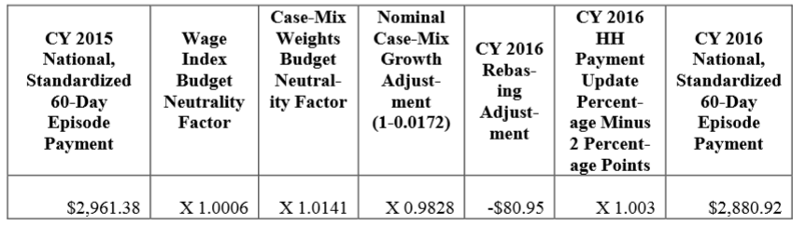
Source CMS

CY 2016 Home Health Market Basket Update

The ACA requires that the market basket update for HHAs be adjusted by changes in economy-wide productivity for CY 2016 (and each subsequent calendar year). The CY 2016 home health market basket (2.9 percent) adjusted for multifactor productivity or MFP (0.6 percentage points) would result in a net 2.3 percent payment update.

As a reminder, the ACA Section 1895(b)(3)(B) requires that the home health market basket percentage increase be decreased by 2 percentage points for those HHAs that do not submit quality data as required by the Secretary.

CY 2016 Home Health Wage Index
Last year CMS proposed to change the wage index based on the newest Core Based Statistical Area (CBSA) changes for the HH PPS wage index and Office of Management and Budget (OMB) delineations, as described in OMB Bulletin No. 13-01. CMS believed that using the most recent OMB delineations will create a more accurate representation of geographic variation in wage levels. Therefore, last year the changes included a wage index using a blended wage index for a 1-year transition. CMS referred to this blended wage index as the CY 2015 HH PPS transition wage index.

For CY 2016 CMS is proposing the wage index be fully based on the revised OMB delineations adopted in CY 2015.
For a complete run down county by county, see Appendix A.

CY 2016 National Per Visits Rates
The national per-visit rates are used to determine Low Utilization Payment Adjustment (LUPA) rates for episodes with four or fewer visits, and are also used to compute imputed costs in outlier calculations. The per-visit rates are paid by either the type of visit or the home health discipline. They include: home health aide, medical social services, occupational therapy, physical therapy, skilled nursing, and speech-language pathology.

CMS calculated the CY 2016 national per-visit rates by starting with the CY 2015 national per
-visit rates. Then they applied a wage index budget neutrality factor of 1.0006 to ensure budget neutrality for LUPA per-visit payments, and then increased each of the six per-visit rates by the maximum rebasing adjustments, and the proposed market basket update. The LUPA per-visit rates are not calculated using case-mix weights. See Table 3.

Table 3 - CY 2016 National Per-Visit Payment Amounts for HHAs That DO Submit the
Required Quality Data
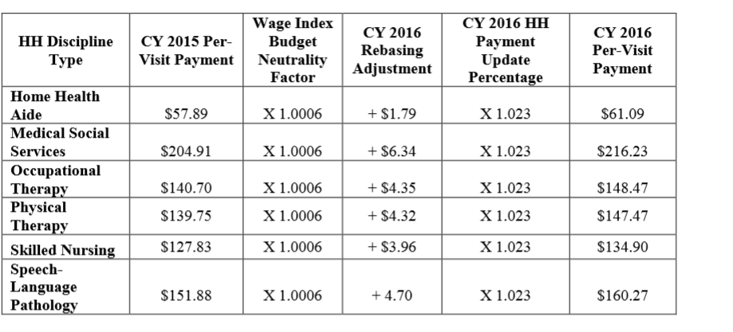
Source: CMS

Please note the CY 2016 national per-visit rates for an HHA that does not submit the required quality data is updated by the CY 2016 HH payment update (2.3 percent) minus 2 percentage points. See Table 4.

Table 4 - CY 2016 National Per-Visit Payment Amounts for HHAs That DO NOT Submit the Required Quality Data 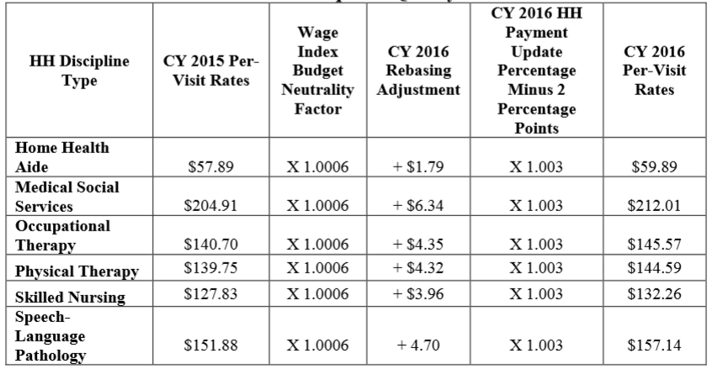
Source: CMS

CY 2016 Low- Utilization Payment Adjustment (LUPA) Add-On Factors
The LUPA methodology in the proposed CY 2016 HH PPS is the same as the LUPA “add-on-factor” in the 2014 final HH PPS rule. In the CY 2014 HH PPS, CMS changed the methodology for calculating the LUPA add-on amount by finalizing the use of three LUPA add-on factors:
- 1.8451 for Skilled Nursing;
- 1.6700 for Physical and Occupational Therapy; and
- 1.6266 for Speech Language Pathology.

CMS then multiplied the per-visit amount for the first SN, PT, OT or SLP visit in a LUPA episode that occurs as the only episode in a sequence of adjacent episodes by the appropriate factor to determine the LUPA add-on payment amount. For instance, for a LUPA episode that occurs as the only episode or an initial episode in a sequence of adjacent episodes, if the first skilled visit is SN, the payment for that visit would be $248.90 (1.8451 multiplied by $134.90), subject to the area wage adjustment. The LUPA per-visit rates are not calculated using case-mix weights.

CY 2016 NRS Payment Rates
CMS determined the proposed CY 2016 NRS conversion factor by starting with the 2015 NRS conversion factor of $53.23 and applying the negative 2.82 percent rebasing adjustments and then updating the conversion factor by the CY 2016 HH payment update of 2.3 percent. The proposed NRS conversion factor is shown in Table 5 for those HHAs who submit the required quality data and in Table 6 for those HHAs that do NOT submit the required quality data.

Table 5 - CY 2016 NRS Conversion Factor for HHAs that DO Submit the Required
Quality Data
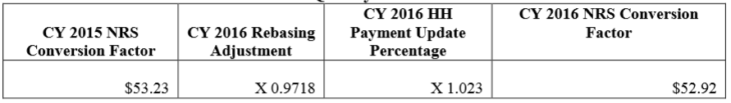
Source CMS

Table 6 - CY 2016 NRS Conversion Factor for HHAs that DO Submit the Required Quality Data 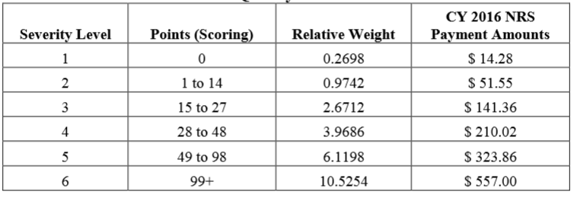
Source CMS

CY 2016 Rural Add-On Extended
Section 3131 (c) of the ACA and amended section 421 (a) of the Medicare Modernization Act mandated a 3 percent add-on to payment amounts for HH services furnished in a rural area for episodes and visits ending on or after April 1, 2010 and before January 1, 2016. This has been extended for HH services provided in a rural area for episodes and visits ending before January 1, 2018.

The following Tables 7 and 8 show the proposed payment amount in rural areas.

Table 7 - CY 2016 Payment Amounts for 60-Day Episodes for Services Provided in a
Rural Area
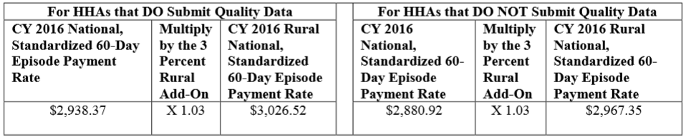
Source CMS

Table 8 - CY 2016 Per-Visit Amounts for Services Provided in a Rural Area
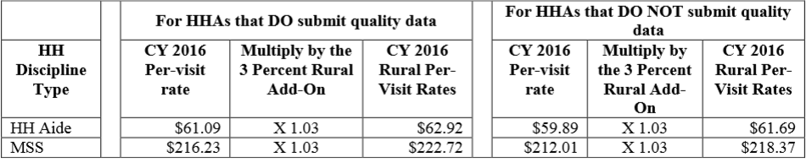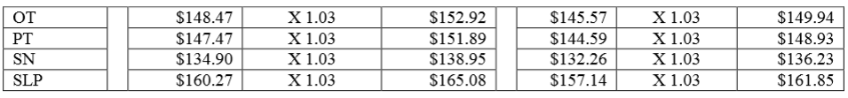
Source CMS

Payments for High-Cost Outliers under the HH PPS/ Fixed Dollar Loss (FDL) Ratio and Loss Sharing Ratio

CMS continues their policy first implemented in CY 2011 by targeting up to 2.5 percent of estimated total payments to be paid as outlier payments and then applying the 10 percent agency-level outlier cap. The 10 percent cap is a result of excessive growth in outlier payments, primarily the result of unusually high outlier payments in a few areas of the country.

In the proposed rule CMS would continue the Fixed Dollar Loss (FDL) ratio at the same amount of 0.45 and a loss-sharing ratio of 0.80. CMS believes this is appropriate given the percentage of estimated outlier payments.

Technical Regulation Text Changes

CMS is proposing several technical corrections in Section 484 to better align the payment requirements with recent statutory and regulatory changes for HH services. They include the following:

- Propose changes to § 484. 205(e) to state that estimated total outlier payments for a given calendar year are limited to no more than 2.5 percent of total outlays under the HH PPS, rather than 5 percent of total outlays, as required by section 1895(b)(5)(A) of the Act and as amended by section 3131(b)(2)(B) of the Affordable Care Act.
- Similarly, CMS proposes to specify in § 484.240(e) that the fixed dollar loss and the loss sharing amounts are chosen so that the estimated total outlier payment is no more than 2.5 percent of total payments under the HH PPS, rather than 5 percent of total payments under the HH PPS as required by section 1895(b)(5)(A) of the Act as amended by section 3131(b)(2)(B) of the Affordable Care Act.
- CMS also propose to describe in § 484.240(f) that the estimated total amount of outlier payments to an HHA in a given year may not exceed 10 percent of the estimated total payments to the specific agency under the HH PPS in a given year.
- Minor editorial change in § 484.240(b) to specify that the outlier threshold for each case-mix group is the episode payment amount for that group, or the PEP adjustment amount for the episode, plus a fixed dollar loss amount that is the same for all case-mix groups.

In addition to the proposed changes to the regulations pertaining to outlier payments under the HH PPS, CMS is proposing to amend § 409.43(e)(iii) and to add language to § 484.205(d) to clarify the frequency of review of the plan of care and the provision of Partial Episode Payments (PEP) under the HH PPS as a result of a regulatory change in § 424.22(b) that was finalized in the CY 2015 HH PPS final rule (79 FR 66032).

The specifics proposals include:
- change the definition of an intervening event to include transfers and instances where a patient is discharged and goes to to a new HHA during a 60-day episode, rather than a discharge and return to the same HHA during a 60-day episode.
- § 484.220, update the regulations text to reflect the downward adjustments to the 60-day episode payment rate due to changes in the coding or classification of different units of service that do not reflect real changes in case-mix (nominal case-mix growth) applied to calendar years 2012 and 2013, which were finalized in the CY 2012 HH PPS final rule (76 FR 68532). This also includes updating the CY 2011 adjustment to 3.79 percent as finalized in the CY 2011 HH PPS final rule (75 FR 70461).
- § 484.225, eliminate references to outdated market basket index factors by removing paragraphs (b), (c), (d), (e), (f) and (g).
- § 484.230, delete the last sentence as a result of a change from a separate LUPA add-on amount to a LUPA add-on factor finalized in the CY 2014 HH PPS final rule (78 FR 72256).
- Deleting and reserving § 484.245.
CMS is asking for comments on these technical corrections and associated changes.

Home Health Value-Based Purchasing (HH VBP) Model

Background – Last year CMS proposed to implement a value-based purchasing (VBP) model for HHAs similar to what was implemented for Skilled Nursing Facilities (SNF). The intent of the HH VBP was to tie a provider’s payment to its performance in such a way as to reduce inappropriate or poorly furnished care and to reward those providers who provide quality care. Section 3006(b) (1) of the ACA directs the Secretary to develop a plan to implement such a program.

The CY 2015 proposed rule mentioned the hospital-based VBP where 1.25 percent of hospital payments in 2014 were tied to the quality of care that hospitals provide. In the President’s 2015 Budget he proposes VBP should be extended to additional providers including SNFs, HHAs, ambulatory surgical centers, and hospital outpatient departments.

Last year CMS asked for comments and feedback on the elements of the HHA VBP model, size of the payment incentives and percentage of payments that would need to be placed at risk in order to encourage HHAs to make the investments to improve the quality of care and the best approach for selecting states for this pilot and put forth the following limited information:

- HHA VBP model would reduce or increase Medicare payments, in a 5-8% percent range, depending on the degree of quality performance;
- The model would apply to ALL HHAs in each of the projected five to eight states;
- The distribution of payments would be based on quality performance; and
- CMS believes the payment adjustment at risk will provide incentives to HHAs for improved planning, coordination, and management of care.

LeadingAge NY concerns were included in LeadingAge’s national comments. We supported the goals of HH VBP, including the range of five to eight percent dependent upon the degree of the quality performance in the various measures to be selected.

The specific goals outlined in this years’ proposed rule are:
1. Incentivize HHAs to provide better quality care with greater efficiency;
2. Study new potential quality and efficiency measures for appropriateness in the home health setting; and,
3. Enhance current public reporting processes.

CMS is proposing to move forward with the HH VBP in nine states. It would be mandatory for all HHAs in those states to participate, the states that would impacted are: Massachusetts, Maryland, North Carolina, Florida, Washington, Arizona, Iowa, Nebraska, and Tennessee. Each of the 50 states was assigned to nine geographic groups; New York was assigned to Group Two along with Delaware, New Jersey, Maryland, and Pennsylvania. This group was earmarked as tending to have larger HHAs, lower utilization, and providing care to an average number of duals.

CMS is asking for comments on the methodology for selecting the states.

The defined population would include all Medicare beneficiaries being provided care by any Medicare-certified HHA delivering care within the selected states. The HH VBP model would adjust payments upward or downward on an annual basis starting at 5% in 2016 and escalating to 8% in later years. Those HHAs in the nine states would have their Medicare payments tied to quality performance under the new proposed value-based purchasing model. The model would run from Jan. 1, 2016 through Dec. 31, 2022.

CMS is proposing measures that have a high impact on care delivery and support improved outcomes, quality, safety, efficiency and the experience of care for the patient. The measures would be predominantly drawn from the OASIS. CMS is proposing outcome and process measures that have the potential to follow patients across multiple settings. The quality measures are aligned with the six National Quality Strategy (NQS) domains and CMS proposes to filter these NQS domains into four classifications: Clinical Quality of Care, Outcome and Efficiency, Person and Caregiver-Centered Experience and New Measures reported by HHAs. The new measures include:
- Advance Care Planning;
- Adverse Event for Improper Medication Administration and/or Side Effects;
- Influenza Vaccination Coverage for Home Health Care Personnel; and,
- Herpes Zoster (Shingles) Vaccination received by HHA patients.

CMS proposes that all the measures within each classification will be weighted the same for purpose of payment adjustment.

CMS is seeking comments on the proposed weighting methodology.

Evaluation of the HH VBP - CMS also proposes to codify in 484.315(c) that HHAs in the nine mandatory states would be required to collect and report information to CMS necessary for the purpose of monitoring and evaluating the HH VBP model. The focus would be primarily on understanding how successful the model is in achieving quality improvement as evidenced by HHAs’ performance on clinical care process measures, clinical outcome measures, utilization/outcome measures (for example, hospital readmission rates, emergency room visits), access to care, and patient’s experience of care, and Medicare costs. CMS will also watch for unintended consequences.

Home Health Care Quality Reporting Program (HH QRP)

In Section 2(a) of the Improving Medicare Post-Acute Care Transformation Act of 2014 (the IMPACT Act) amended Title XVIII of the Act, in part, by adding a new section 1899B, which imposes new data reporting requirements for certain post-acute care (PAC) providers, including HHAs.

CMS is proposing one standardized cross-setting measure for CY 2016 under skin integrity and changes to skin integrity domain. Measures for the other domains will be addressed through future rulemaking, although CMS is seeking feedback on four future, cross-setting measure constructs to potentially meet requirements of the IMPACT Act specified domains of:

- All-condition risk-adjusted potentially preventable hospital readmission rates;
- Resource use, including total estimated Medicare spending per beneficiary;
- Discharge to the community; and
- Medication reconciliation.

CMS is asking for comments on the proposed constructs.

Form, Manner, and Timing of OASIS Data Submission

Background - The HH conditions of participation (CoPs) at § 484.55(d) require that the comprehensive assessment must be updated and revised (including the administration of the OASIS) no less frequently than: (1) The last 5 days of every 60 days beginning with the start of care date, unless there is a beneficiary-elected transfer, significant change in condition, or discharge and return to the same HHA during the 60-day episode; (2) Within 48 hours of the patient's return to the home from a hospital admission of 24-hours or more for any reason other than diagnostic tests; and (3) At discharge.

It is important to note that to calculate quality measures from OASIS data, there must be a complete quality episode, which requires both a Start of Care (initial assessment) or Resumption of Care OASIS assessment and a Transfer or Discharge OASIS assessment. Failure to submit sufficient OASIS assessments to allow calculation of quality measures, including transfer and discharge assessments, is a failure to comply with the CoPs.
Last year, CMS reported information on a study performed by the Department of Health & Human Services, Office of the Inspector General (OIG) in February 2012 to: (1) Determine the extent to which HHAs met federal reporting requirements for the OASIS data; (2) To determine the extent to which states met federal reporting requirements for OASIS data; and (3) To determine the extent to which CMS was overseeing the accuracy and completeness of OASIS data submitted by HHAs. As previously reported the home health market basket percentage increase may be reduced by two percent if a HHA does not submit the OASIS data. Again last year CMS finalized the proposal to define the quantity of OASIS assessments each HHA must submit to meet the pay-for-reporting requirement.

The performance system is based on the principle that each HHA is expected to submit a set of “two matching assessments” for each patient admitted to the HHA. These matching assessments together create what is considered a quality episode of care, consisting ideally of a Start of Care (SOC) or Resumption of Care (ROC) assessment and a matching End of Care (EOC) assessment.

However, it was determined that there are several scenarios that could meet this matching assessment requirement of the new pay-for-reporting performance requirement. These scenarios of quality assessments are defined as assessments that create a quality episode of care during the reporting period or could create a quality episode if the reporting period were expanded to an earlier reporting period or into the next reporting period. According to CMS the following seven types of assessments submitted by a HHA fit this definition:

- A Start of Care (SOC) or Resumption of Care (ROC) assessment that can be matched to an End of Care (EOC) assessment. These SOC/ROC assessments are the first assessment in the pair of assessments that create a standard quality of care episode described above.
- An End of Care (EOC) assessment that can be matched to a Start of Care (SOC) or
Resumption of Care (ROC) assessment.
- A SOC/ROC assessment that could begin an episode of care, but the assessment
occurs in the last 60 days of the performance period.
- An EOC assessment that could end an episode of care that began in the previous
reporting period, (that is, an EOC that occurs in the first 60 days of the performance period). This is labeled as an Early EOC quality assessment.
- A SOC/ROC assessment that is followed by one or more follow-up assessments, the
last of which occurs in the last 60 days of the performance period.
- An EOC assessment is preceded by one or more follow-up assessments, the first of
which occurs in the first 60 days of the performance period. This is labeled an EOC Pseudo Episode quality assessment
- A SOC/ROC assessment that is part of a known one-visit episode. This is labeled as a
One -Visit episode quality assessment.

SOC, ROC, and EOC assessments that do not meet any of these definitions are labeled as
Non-Quality assessments.

Compliance with this performance requirement can be measured through the use of an
uncomplicated mathematical formula. This pay-for-reporting performance requirement metric
has been titled as the “Quality Assessments Only” (QAO) formula because only those OASIS
assessments that contribute, or could contribute, to creating a quality episode of care are included
in the computation.

The formula based on this definition is QAO = (# of Quality Assessments) divided by (# of Quality Assessments plus # of Nonquality Assessments).

CMS’s goal is to require all HHAs to achieve a pay-for-reporting performance
requirement compliance rate of 90 percent or more, as calculated using the QAO metric
mentioned above.

CMS plans to follow the pay-for-reporting requirements of:

- Assessments submitted on or after July 1, 2015 and before June 30, 2016 with appropriate start of care dates, HHAs must score at least 70 percent on the QAO metric of pay-for-reporting performance requirement or be subject to a 2 percentage point reduction to their market basket update for CY 2017.
- The performance threshold at 80 percent for the reporting period from July 1, 2016 through June 30, 2017 or be subject to a 2 percentage point reduction to their market basket update for CY 2018.
- For the reporting period from July1, 2017 through June 30, 2018 and thereafter, CMS is proposing the performance threshold would be 90 percent or be subject to a 2 percentage point reduction to their market basket update for CY 2019.

CMS states that during this initial performance period for the pay-for-reporting performance requirement would be July 1, 2015 through June 30, 2016 and they have scheduled Open Door Forums and webinars to educate HHA personnel as needed about:
- the pay-for-reporting performance requirement program; and
- the pay-for-reporting performance QAO metric; and

CMS will distribute individual provider preview reports and has posted a report which provides a detailed explanation of the methodology.

CMS welcomes comment on the proposal to implement an 80 percent Pay-for-Reporting Performance Requirement for Submission of OASIS Quality Data for Year 2 reporting period July 1, 2016 to June 30, 2017.

Home Health Care CAHPS Survey (HHCAHPS)

CMS continues with the policy from the CY 2015 HH PPS final rule, that the home health quality measures reporting requirements for Medicare-certified agencies include the Home Health Care CAHPS® (HHCAHPS) Survey for the CY 2016 Annual Payment Update (APU).

CMS has previously stated that Medicare-certified HHAs are required to contract with an
approved HHCAHPS survey vendor. This requirement continues, and Medicare-certified
agencies also must provide on a monthly basis a list of all their survey-eligible home health care
patients to their vendors.

Please note the submission dates for the HHCAHPS through CY 2018. HHAs are required to submit their HHCAHPS data files to the HHCAHPS Data Center for the HHCAHPS data for specific time periods. The deadlines are firm; no exceptions are permitted.

Conclusion

The proposed rule focuses on many of the same areas of HH PPS as before; case-mix weights, non-routine medical supplies (NRS), home health market basket, per-visit payment rates. We remain concerned about rebasing and the impact it has on our HHAs. We are evaluating the proposed technical changes and we are also carefully evaluating the new HH VBP model and the evaluation component given its potential impact to HHAs in New York.

Please contact LeadingAge national at congress@leadingage.org and me at cudell@leadingageny.org to share your recommendations on the proposed rule and, especially, let us know what the impact of rebasing means to your agency and the questions or concerns you may have on the HH VBP model.

For any additional comments or questions regarding the CY 2016 HH PPS proposed rule, please contact Cheryl Udell at cudell@leadingageny.org or at 518-867-8871. LeadingAge NY will provide an analysis of the final rule when it becomes available later this year.

